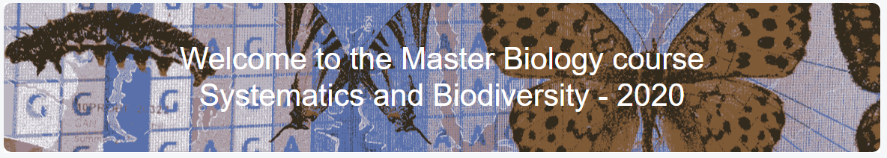

Species Distribution Modelling using MAXENT

Modelling your species habitat suitability under present and future climate conditions

Practical Manual, 2020

Nuno César de Sá ([n.q.cesar.sa@cml.leidenuniv.nl](mailto:n.q.cesar.sa@cml.leidenuniv.nl))

Rosaleen March, PhD ([r.g.march@cml.leidenuniv.nl](mailto:r.g.march@cml.leidenuniv.nl))

Found a “bug”? Let us know!

Contents:

Introductory notes: 3

Setting up your working environment: 4

Occurrence data 7

Downloading occurrence data from GBIF 7

Preparing occurrence data for MAXENT 10

Environmental data 13

Downloading Environmental data 13

Loading environmental data in R 19

Cropping/clipping Environmental data in R 21

Selecting environmental variables 23

Checklist before MAXENT: 29

MAXENT – Maximum Entropy Modelling: 30

MAXENT Intro: 31

Setting up MAXENT: 34

MAXENT – Common warnings & errors messages: 37

Validating Species Distribution Models: 38

Interpreting MAXENT report & outputs: 42

Calculating range-shift changes and the change map: 49

Exporting final data to more GIS friendly files: 52

A curve ball: 55

Common R commands: 56

# Introductory notes:

This manual represents the example that the tutors will show during the class. You should **adapt it to your chosen species** and folder structure. This manual should be enough to give you an example of all the options and alternatives available to you for setting up your own experiment and then proceed for your final report. The next figure is a general overview of the main steps but do notice that each step has multiple steps within:

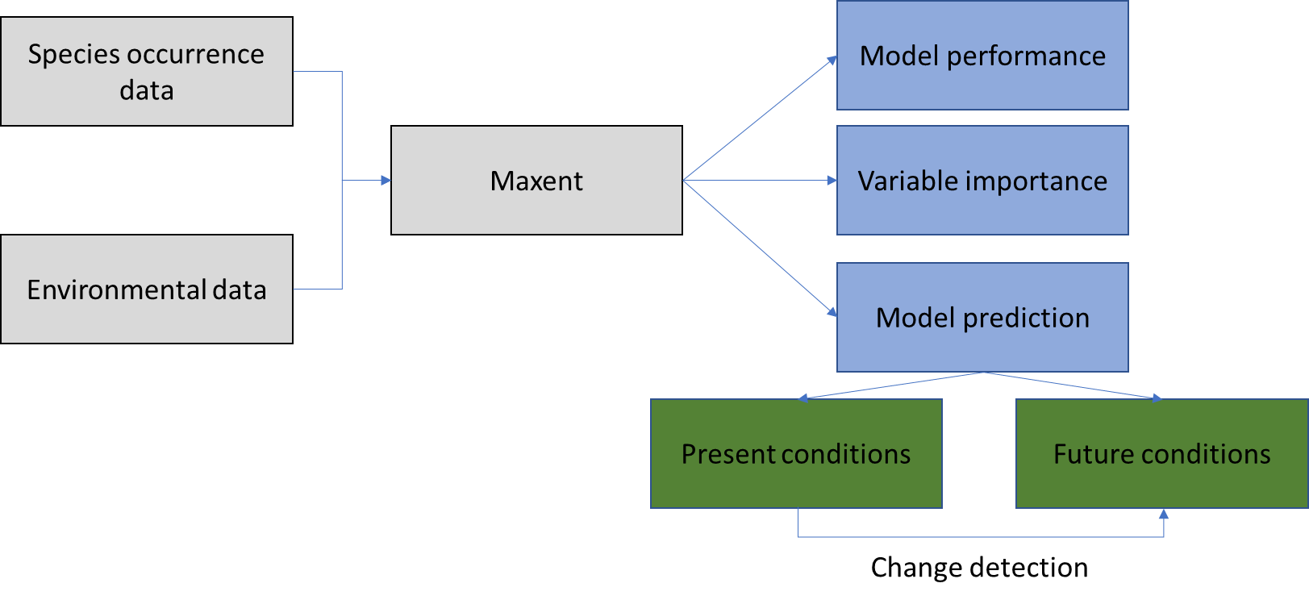

During this example, we will go through each of the above steps. *The* **species selected is the** [***Rhinolophys Euryale***](https://en.wikipedia.org/wiki/Mediterranean_horseshoe_bat), the Mediterranean horseshoe bat. As the name implies, it is a type of bat characteristic of the Mediterranean region, thus is inhabits in a region with dry summers and wet winters. Still these bats live in caves and near wooded areas, so that might play a role in their distribution. In this tutorial we will explore how the species distribution is going to change in the coming 50 years if we maintain a “business as usual” attitude regarding climate change mitigation.

In previous lectures you have selected (or has been selected for you) a species. During the course Systematics in Biodiversity you have been working with different aspects of that same species. **In this case it is not different: this exercise should be made with that species** – so you need to adapt from the examples given in this tutorial.

# Setting up your working environment:

Take some time to organize your working folders as this will facilitate your work for your own species and to be organized for the report later. It’s always good to have a folder to store the data “as is”, before any processing in case something goes wrong somewhere. It is also useful to have separate folders and subfolders for different data types, so it is easier to find them when needed. Finally, it is also useful to have a separate folder for the results itself and separate subfolders when necessary.

Following these general ideas, in this tutorial we opted for the following folder structure and we recommend that you use the same or something similar. The similar it is to the shown structure, the less customization of the R scripts will be needed later:

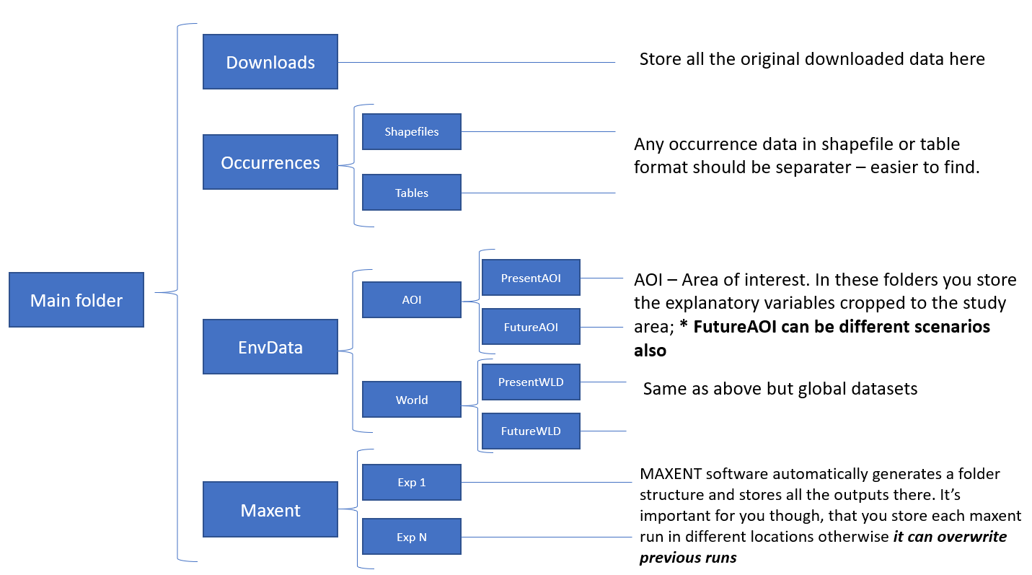

You can either create this folder structure by hand or you can just program it in R and adapt it to your own workspace. We provided R script (**00_SettingUpWorkspace.R)** to organize this for you**.** In our case, the main folder is: C\Practical but you can use any “main folder”.This will help you keep everything organized and facilitate when you are writing your report. **The recommended script will set up the “general” work environment and then you can do any adaptations you consider necessary by hand e.g. adding different folders for different scenarios.**

NOTICE: MAXENT names the output files based on the last subfolder. This means that you should **name your scenarios folder**: ScenarioX, ScenarioY, ScenarioZ.. (where X,Y,Z are different, can be a number 1,2,3 or more clearly: y50,y100. Whatever you think is better for yourself. Notice we are talking of **FOLDERS and not FILENAMES**. If you do not do this, then, MAXENT will overwrite the different scenarios.

NOTICE2: **Subfolder names must be different but, the files inside are the exact opposite, they must have precisely the same name**. This is because otherwise MAXENT does not identify which files to use for the models. So the files inside ScenarioX, ScenarioY, ScenarioZ.. must have the same name e.g. Bio01, Bio02, Bio03.

Besides the main structure above, a specific separate folder for the scripts can be useful to keep everything organized. The script for this section is named **00_SettingUpWorkspace**. Open and investigate it.



The first lines tell R to create a directory named “Practical” in the C drive using the [dir.create()](https://www.rdocumentation.org/packages/base/versions/3.6.2/topics/files2) command and then set this directory as the working directory with the [setwd()](https://stat.ethz.ch/R-manual/R-patched/library/base/html/getwd.html) command.

**Using setwd can be very practical since we can easily access all folders and data more easily due to the “relative paths” concept.** Whatever folder is inside “Practical” can now be accessed by using “./” and then the folder name, e.g. “./<foldername>” instead of having to write the full path starting in the Root drive, e.g. “C:/Practical/<foldername>”.

This is very practical, for example, if your working folder is in the desktop, documents folder or buried deep inside each of the folders you have for your different classes. **You can adapt the “setwd” command for your case, wherever you are working and storing your data**.

This means that by using setwd you can set your default folder “anywhere” in your disk (remember, there are protected folders which do not allow unauthorized writing e.g. the folders where your operating system is stored).

The remaining sections of the script create the remaining folder structure as shown initially:

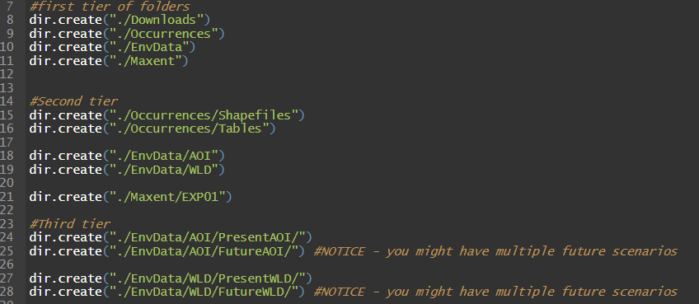

NOTICE: The last folder is named “future” only, but you can adapt these later to be the different environmental scenarios you would like to test. You can have as many “scenarios” to test as you want so it is ok to have different folders for each. Remember though that MAXENT will use the last subfolder name to identify the scenario and this means if you have scenarios with the same subfolder name they will be overwritten in the final output. **The recommendation is to add some extra indicator as I did above: “WLD” for raw global datasets and AOI for cropped areas.**

If you followed my suggestions, then the final folder structure should look something like this:

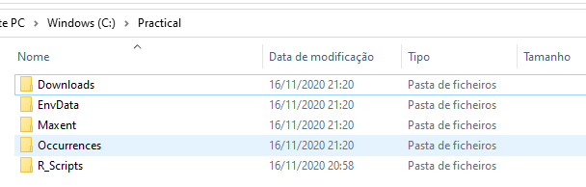

**NOTICE:** There are some specific **differences between running R in windows and R in MAC OS**. You can find their explanation and examples [here](https://datadojo.dev/2018/12/07/changing-working-directories/) and a description of shortcuts [here](https://libguides.libraries.claremont.edu/c.php?g=480755&p=3350989). Let us know if you are having issues in adapting the code to MAC OS and we will help you

**A common mistake in this section:**

In R (and almost every other programming language) the symbols “\” and “/” have different meanings.

“\” is a special command that tells R to “exit” the regular execution during the compiling procedure. This exit command can be used to tell the computer that special characters are appearing, e.g. for &, % or $ to be correctly compiled they often must be written as \& \% or \%. **If you use the string “\Practical” in a function you will have the error: \P is an unrecognized escape…“** – R is telling that it does not know what to do with P as an escape character. **The correct way to do this in R is to either use two “\\” or “/”. The following example shows this common error and how to avoid it:**

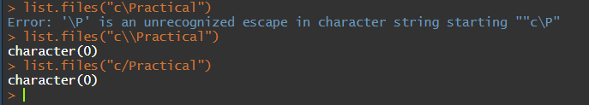

# Occurrence data

## Downloading occurrence data from GBIF

Data download and preparation was part of a previous GIS practical exercise, so we expect that you have already done this before. This section is here in any case, but it does not include an exploitation of the occurrence data in a GIS. **If you have prepared your data before, as we expect you to have done, skip this section** **but do confirm that your species occurrence ready to be used in MAXENT (section: *Preparing data for Maxent*)**

Species occurrence data will be downloaded from the Global Biodiversity Information Facility which “*is an international network and data infrastructure funded by the world's governments and aimed at providing anyone, anywhere, open access to data about all types of life on Earth” (*[*https://www.gbif.org/what-is-gbif*](https://www.gbif.org/what-is-gbif)*)*. There you will be able not only do find information about species occurrences but also a lot of extra information about the different species which surely will be useful for your report writing phase. More details on the organization can be found on its webpage and its recommended that you spend some time during this course investigating what is GBIF and what you can find on it.

Step by step:

* Go to GBIF [www.gbif.org](https://www.gbif.org/)
  + Create an account and login so you can download data
* Enter **your species name** on the search field.
  + For the purpose of example, we will model the distribution of the bat *Rhinolophys Euryale*

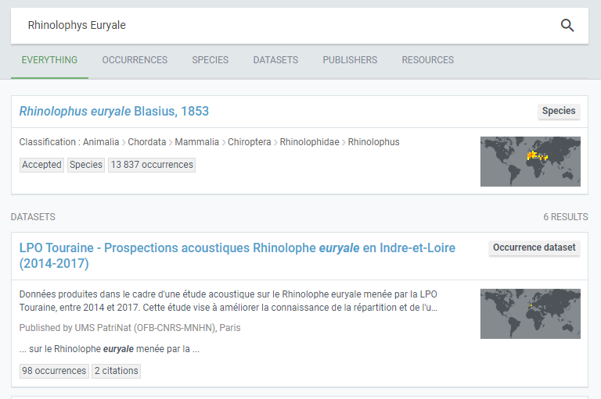

You will likely be shown several options now. Some of them refer to occurrence data, while other refer to other information. It might also ask to specify further the species name. **Navigate through these choices but keep all this in mind as it can be useful for your report later**. **Proceed from this section by selecting the option that provides access to the occurrence information (likely you can see a map with “colors” as in the previous figure).** It is also possible that you find multiple cases with occurrence data because there are multiple synonyms for the species – this can be useful to find extra occurrence data.

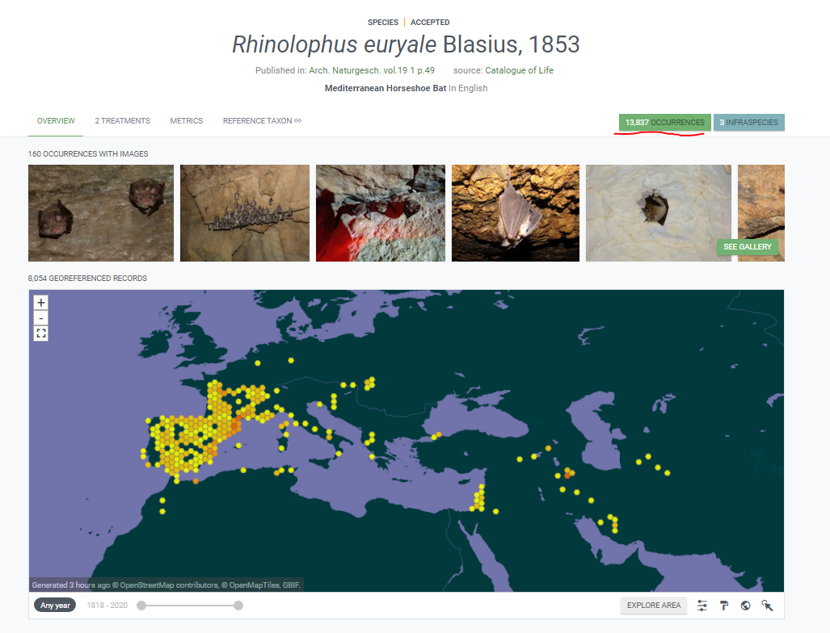

This map already allows you to have an idea of the regions where the data is coming form. You might also see “weird” occurrences such as land animals appearing in the middle of the ocean or lions in London. This happens because the raw data often is not either properly georeferenced or some other times it is georeferenced to a botanical garden, a museum, or a zoo. **It’s important to remember that while GBIF did an excellent job in gathering all these data, it’s always possible that some error remain and it’s up to you to be able to identify these and address them properly.**

* Press “<number> occurrences” green button on the top right to proceed to the data download section.
* The next section will show you more information about the actual data that GBIF has collected. And more filtering options are given on the left panel.

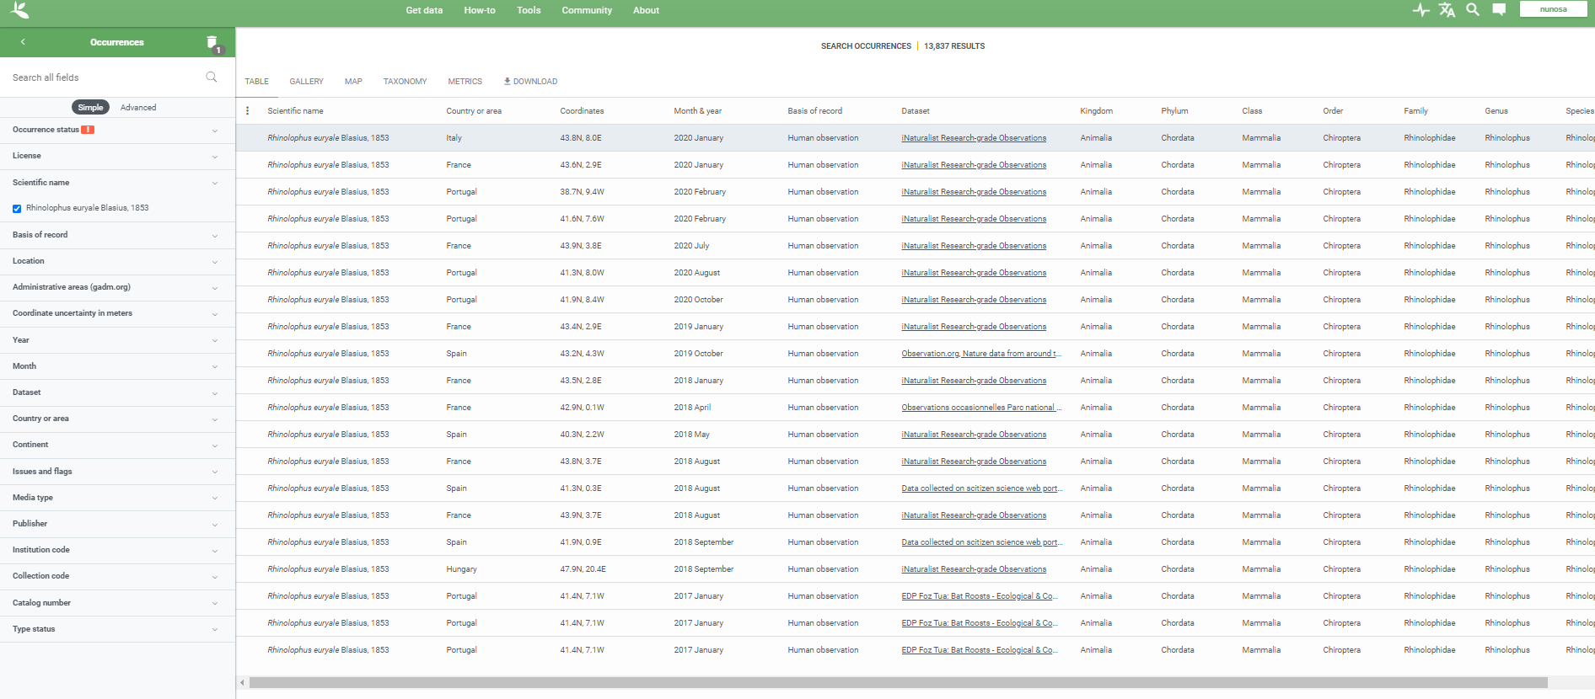

* **Explore these filtering options and how they work.** What they will do is help you do a quick cleaning of the data available in the repository.
  + Keep track of the filtering options you have selected for your species and use that information on your report.h
* For our case, we choose the following:
  + In **“occurrence status”** select “Present”
  + In **“Scientific name”** select the names that you are interested on.
  + In **“Location”** select “Including coordinates”
  + (Optional) In **“Basis of record”** you can see that some records will be “preserved specimens”. This might indicate that they are being stored in a museum but often the specimen is stored there but the coordinates refer to the location where it was collected. (Often, only through GIS this is possible to address).
  + (Optional) In “Issues and flags” pay attention to any special issue (e.g. “Zero coordinate”) and do not tick those options. Beware that in this case you need to activate the filter to select.

**Once you are satisfied with the filters, press on the download button (top of the data table) and download the “simple” version. Once the data is processed, you will be notified by email.**

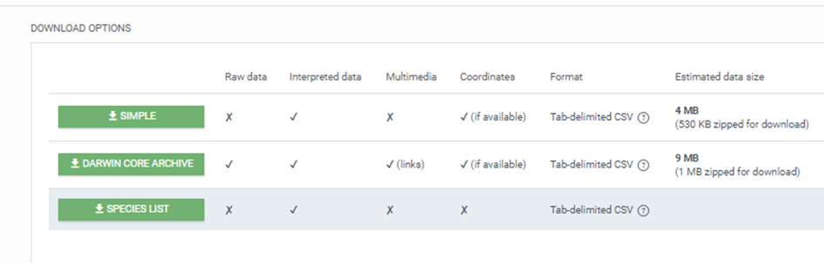

Once you have received the email and completed the download, extract the data to the table folder (if you used the folder structure suggested before) and you can begin to explore what you have.

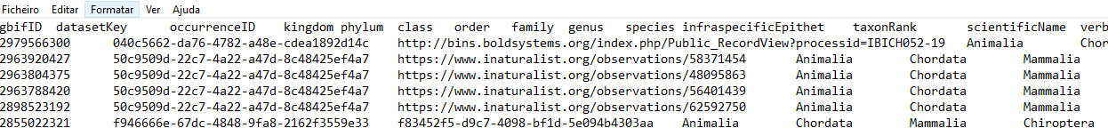

## Preparing occurrence data for MAXENT

The data is delivered in “Comma separated values” (.csv) using “tabular” separators and points as decimals. Some excel version (and operating systems) will expect a different format and you will not be able to open the file just by clicking on it.

In general:

* “USA” format: decimals as points and commas to separate values
* “EU” format: decimals as commas and semicolons to separate values
* “Tabular” format: decimals as commas/points and spaces (tabular spaces) to separate values

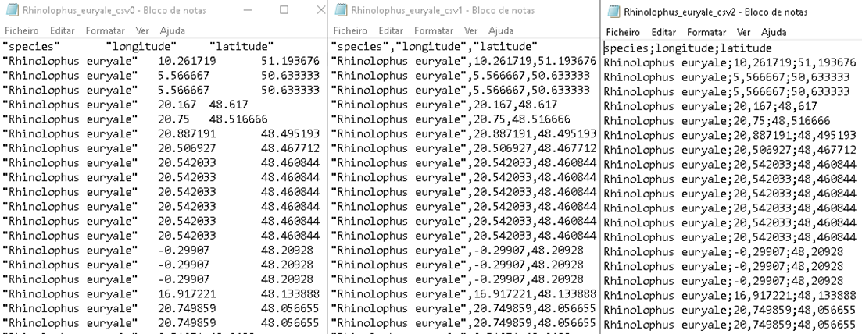

All formats can be useful in different context, so its ok if you keep examples of all of them. **It is also possible that specific software expects specific formats. MAXENT, expects data to be provided in USA format and only 3 columns: Species name, Longitude, Latitude.** In the file, you have also likely noticed that there are lot more field than what is necessary for MAXENT.

MAXENT allows you to input multiple species at the same time and then it will model one, then the next species successively. It is important therefore than in your final table you have one species name for all the occurrences.

PS: An advanced user which wanted to test different sets of occurrence data would use this feature to input every combination of occurrence data all at once.

**Converting between different .csv data formats:**

* Importing in CSV Tab delimited format:
  + Microsoft Excel
    - Open a blank workbook
    - Go to data tab
    - Click button “from text/CSV” in the General External or “get and transform” data section
    - Select your CSV file
    - Follow the Text import wizard and adapt to your case.
    - Save your file with a different name
      * Recommended: add an indicator in the end of the file e.g. species_csv1.csv for **USA type data (as is the case of this tutorial)**
        + This will help you maintain your folder and data organized
  + Notepad:
    - Open in notepad and use the substitutions functions to correct the decimals and separators
  + Using R:
    - Adapt from example in file: Saving_CSV_files.R
    - Open GBIF file: Read the file using read.csv or read.table adapted to NA style
    - Save corrected file: Write the file opened before to your disk using: write.csv(US Style) or write.csv2(EU style) or write.table(Customizable) depending on what file type you want to save it to (remember, MAXENT will require US Style).

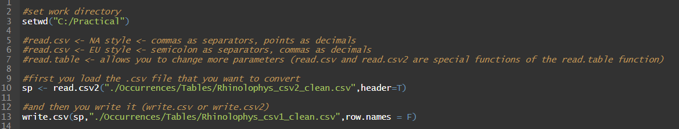

In my case, the Operating System is in Portuguese language, so my data is read by excel directly only if I use the EU type format. Also notice that the example above is already for the “clean” dataset example. You can adapt the code for any of your cases, including data that was just downloaded from GBIF. So in my case, I need to convert my final point data into US format by using the write.csv command (it’s a special version of the write.table command in R). In your case it might be different, check the command details to understand how to adapt: [write.table](https://www.rdocumentation.org/packages/utils/versions/3.6.2/topics/write.table)

**Prepare your data for MAXENT:**

Once the previous details on the data format are sorted and excel is able to open it, you need to:

* Only have 3 columns: **species, longitude, latitude (follow this order precisely)**
  + Species: species name, no spaces (underscores not recommended) and make sure its only one species
    - E.g. *Rhinolophys Euryale* becomes Rhinolophys
  + Longitude and latitude are obvious
* **Save your file as .csv** but before saving make sure that:
  + Is there only 1 name for the species? If not, correct for this, its recommended to use a simple version of the name without any underscore: e.g. Rhinolophys
  + Are there missing numbers on the latitude/longitude rows?
  + Is there text on the latitude and longitude rows?
  + Some of these errors occurred because of problems or mis-formatting on the previous step, investigate if it is possible to correct them or not, otherwise remove the problematic rows.
* In the end, the .csv should look like this (when open with the notepad):

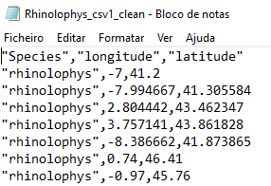

When you are finished, save your file as .csv and give it an appropriate name with perhaps **a tag indicating the data format type or if there was any important detail.** Do not use “strange” characters when naming the file, such “&” or “#” or “_” or “/” because these might create conflicts later.

* If you excel saves the .csv file into a format different than the USA style, then you need to use one of the previous steps to convert it to USA style
* **If you cleaned your data using GIS (as you should have done in a previous practical)** and exported as table .txt or .csv, confirm it is USA style before proceeding

Here you could (should) load your data in a GIS (e.g. ArcGIS or QGIS) and explore your data further to find occurrence data that is out of place. **This data quality verification is actually part of the practical GIS exercise.**

Some of the more common problems with occurrence data from GBIF are:

* Data located in museums, botanical gardens, a zoo, or any other type of collections.
* Data in absurd locations: Sea (land animals), 0º latitude and 0º longitude, in unexpected continents.

These are the easy problems, but more complex problems can exist. For example, occurrences in locations where the species has been identified as exotic or invasive. What to do in these cases? Should “exotic” occurrences be excluded? ([Dinis, 2020](https://www.frontiersin.org/articles/10.3389/fevo.2020.576667/full)) Another example is having both citizen observation and Atlas data at the same time ([César de Sá, 2019](https://link.springer.com/article/10.1007/s10530-019-01962-6)) . Often these problems the actual objective of the research.

When you are finished with this analysis, just save those occurrence points into a .**csv in the NA format following the previous steps and proceed with your analysis**.

# Environmental data

## Downloading Environmental data

There are multiple sources for environmental data to be used in species distribution models, for example [CHELSA](https://chelsa-climate.org/) is a more recent provider that is becoming increasingly used. Also, these data sets can be created by the researchers themselves using other sources such as Remote Sensing data.

In this case, we will use the most commonly used data source for SDM: Worldclim - <https://worldclim.org/> which gathers historical climate data for land areas ([Hijmans, 2005](https://rmets.onlinelibrary.wiley.com/doi/pdf/10.1002/joc.1276)) as well as future predictions using different [General Circulation Models](https://en.wikipedia.org/wiki/General_circulation_model#:~:text=A%20general%20circulation%20model%20(GCM,(radiation%2C%20latent%20heat).) (GCM) and different [Shared socio-economic Pathways (SSPs)](https://www.carbonbrief.org/cmip6-the-next-generation-of-climate-models-explained). Important to detail that each SSP corresponds to different idealized strategies do address carbon emissions. **For your research, we encourage everyone to use the same GCM -** [IPSL-CM6A-LR GCM](https://agupubs.onlinelibrary.wiley.com/doi/full/10.1029/2019MS002010) **- and use at least the SSP 3.7-0 (“a rocky road”) scenario but you are free (and encouraged) to explore different SSP.**

Step by Step:

* Go to <https://worldclim.org/> and press on the “historical data”



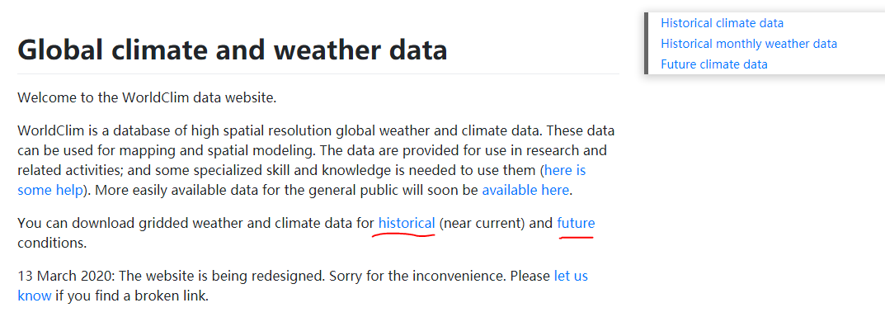

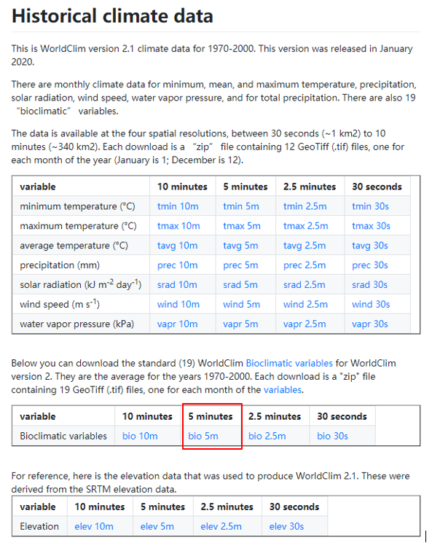

Most variable names and meaning are intuitive (…minimum temperature…) **but notice that each variable has multiple rasters representing monthly means for the historical period** (1970-2000).

The only non-intuitive variable name is for the Bioclimatic variables which represent **“climate indices that highlight climate conditions best related to species physiology options”** ([USGS,2012](https://pubs.usgs.gov/ds/691/ds691.pdf))**. These are the variables that should be used in this modelling exercise.**

Regarding the spatial resolution, you are given 4 options that represent the resolution (in degrees!) at the equator.

* **Download the 5 minutes spatial resolution Bioclimatic variables (equivalent to ~10km resolution at the equator).**

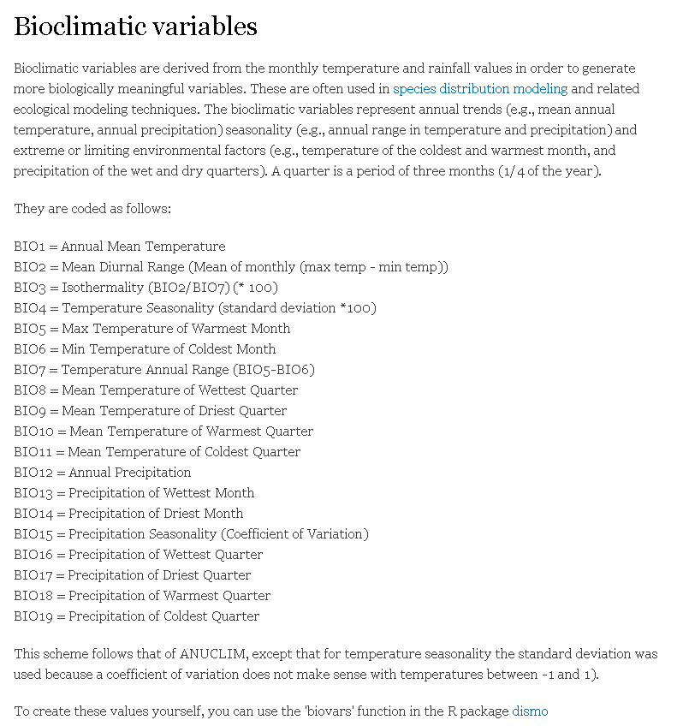

**Take note of the codes and meanings of each variable**. Machine learning models always find a way to fit whatever data you give to them which means that in theory you simply add more environmental data to your model, and it will apparently improve. But of course, too much data implies that the model will fit to spurious relationships between datasets: remember correlation is not causality. **The variables you will be using on your model should provide a reasonable explanation of the species ecology.**

For example, if it is a plant that requires more precipitation in the summer, it is reasonable to consider BIO17 and BIO12. From a statistics perspective, if you use both you run into the risk of overfitting so you should be parsimonious and choose either. Here is where the ecologist in you comes into play, you must be able to make those decisions based on the knowledge available on the species. Later you will also see some statistical tests to try to know if the risk of interactions between variables is too high.

Let us download the future scenarios:

* Go to “Future Climate data” in the <https://worldclim.org/> website:

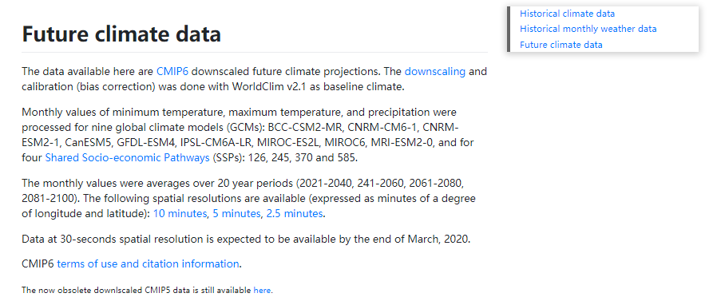

General Circulation Models (GCM) are advanced climate models that simulate the planet’s atmosphere. **We highly insist that everyone uses** [IPSL-CM6A-LR GCM](https://agupubs.onlinelibrary.wiley.com/doi/full/10.1029/2019MS002010) **for this report** but to remember to provide some details about the GCM model based on the scientific publication.

Shared Socio-economic Pathways (SSP) represent different paths our planet can take regarding Carbon emissions: [CarbonBrief CMIP6](https://www.carbonbrief.org/cmip6-the-next-generation-of-climate-models-explained). ***Everyone should at least use scenario*** [***SSP3-7.0***](https://gmd.copernicus.org/articles/12/1443/2019/gmd-12-1443-2019-f08-high-res.pdf) ***(“a rocky road”).*** But you are highly encouraged to use more scenarios!

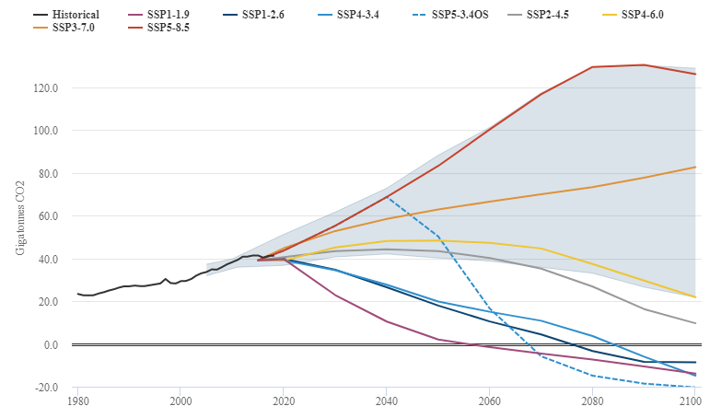

* **Select the 5 minutes spatial resolution (same spatial resolution as the historical data!):**
  + On the next menu you will see multiple “time intervals”. Here you are free to select whichever interval you are interested on but think on what would be a nice research question. **We opted for 2061-2080 interval period (so, ~50 years in the future).**

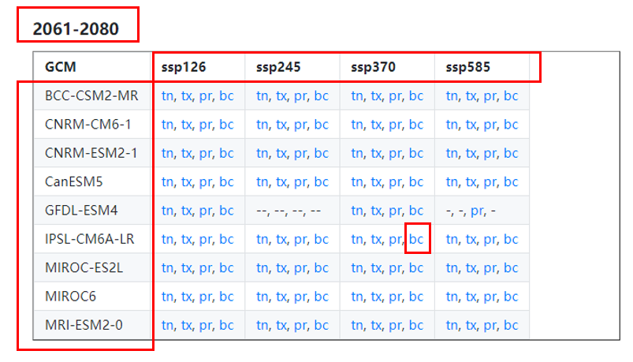

For each period, you have the only 4 different SSP as columns and GCM as rows. Navigate the page and select whichever scenario you want (remember that at least the **“a rocky road”, ssp370 must be part of your report** and that we recommend everyone using the same GCM IPSL-CM6A-LR). The time interval is up to you. You can use [CarbonBrief CMIP6](https://www.carbonbrief.org/cmip6-the-next-generation-of-climate-models-explained) and the figure before to help you select the scenarios you want to test.

Mixing up different scenarios with different GCM and different time periods would make it hard to define what is being tested. As in any experimental setting, you must maintain some aspects constant.

Still, for your report explain SSP370 and (optionally but very encouraged) **explain how the species distribution is affected by this and other scenarios – it is always a good topic for the report.**

* You must use the same variable names in the future scenarios as in the historical scenarios, so:
  + **Download the Bioclimatic variables (bc) on the scenario(s) and time-period of choice**
  + **Unzip all data on the DOWNLOADS folder** 
    - Next, we will use R to load the data and prepare it for MAXENT. This will include renaming, cropping and saving the files to the different folders we created earlier.
    - Remember, that you can also now create the specific folders on the EnvData subfolder related to each scenario you choose so you can use it later on MAXENT.

**NOTICE:** Worldclim has recently updated their side, so there might be some variation on how and where the data is delivered. Be aware that some steps might vary slightly for different scenarios and resolutions. But understand that the overall idea is the same.

After the download is complete, and you’ve unzipped the files, your DOWNLOADS folder should look like this:

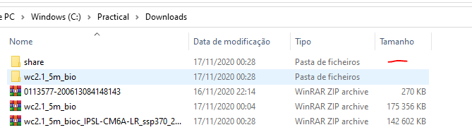

* Wc2.1_5m_bio is the
  + Worldclim historical data version 2.1
  + 5m resolution
  + Bioclimatic variables
  + **Historical data is provided** as multiple rasters where each is one of the bioclimatic variables

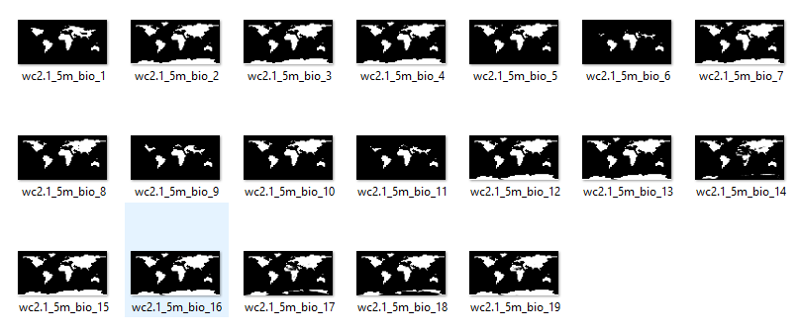

* Share is the SSP scenario folder (it is very deep and full of subfolders)
  + **The future scenarios are provided** as a single raster which has multiple layers inside

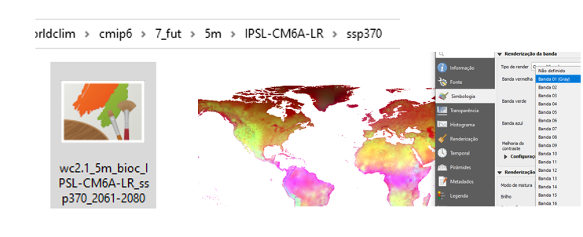

Since the historical and future data are provided in different forms (one as multiple rasters with a single layer and the other with a single raster with multiple layers) we must deal with both datasets using a different approach. The next steps will deal with that problem. – also remember that MAXENT expects environmental data as multiple single layer rasters in .asc (ascii) format.

## Loading environmental data in R

The models should be trained in geographical areas that are like the occurrence data. This is to avoid overfitting behaviour of the model – of course – some species have a global distribution and therefore clipping or cropping that data becomes somewhat moot. Nevertheless, it is beneficial to learn how to do it. The R script for this section is: **01_CroppingEnvVariables.R**

Notice: The paths to the **folders used on this script refer to the folder structure shown before**. It is therefore important that you do any adaptation for it to work on the folder structure you created. **It is highly recommended that you use the latest version of R and R-Studio**. You will likely be prompted or requested to install RTools at some point. To do that, follow these instructions: <https://cran.r-project.org/bin/windows/Rtools/>

**Step by Step:**

* Open R-studio and open the script
  + **Install the packages requested** on the top and any other dependencies that it requests or gives warning for.
  + Load the packages and confirm no error or warning is given.
* Run the next code snippet to load the variables:

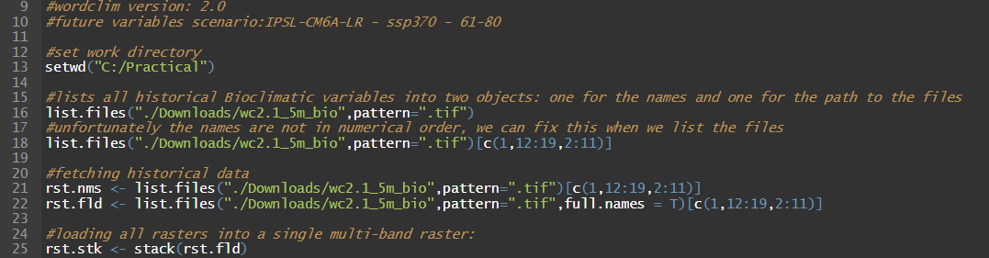

* + Line 13: sets up the R work environment in C:/Practical
  + 16 to 18 create two lists of files, one is the file names and the other is the path to the files.
    - Beware that the bio files are loaded in the wrong order so those numbers: c(1,12:19,2:11) correct for that – the example below exemplifies.

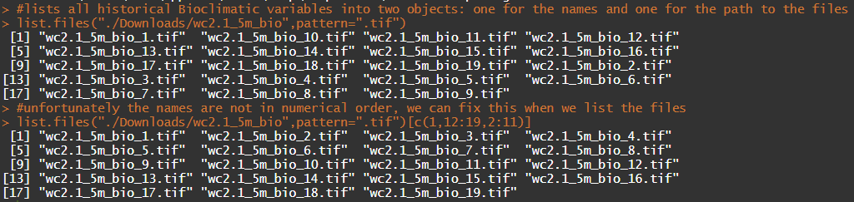

* The first step is to rename all the variables so that they have more meaningful names. **It is vital to ensure that ALL variables in ALL scenarios have precisely the SAME names otherwise MAXENT will not be able to recognize them**
  + The next code snippet renames the historical data raster’s to list of names shown, which are the same as bioclimatic codes.

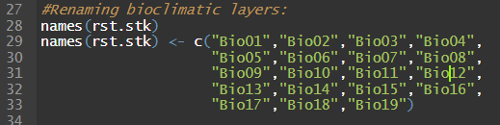

* The same must be done for the future scenario. If you have multiple scenarios, you need to adapt the code to those scenarios independently.
  + First, we load the future scenario multilayer raster



* + Then we check if the layers are in the correct order and, if so, we just rename them

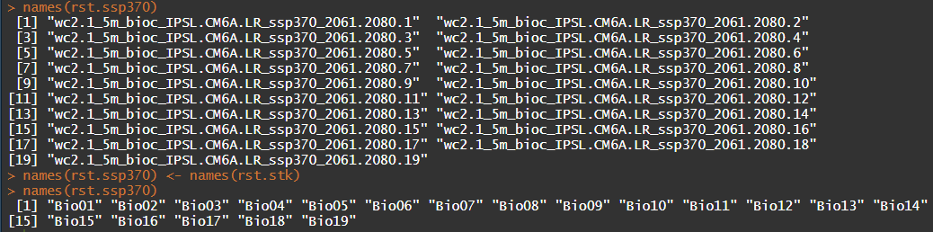

## Cropping/clipping Environmental data in R

This section will use the species occurrence data to **delineate a box around it and use that box to crop (aka clip) the historical and future scenario data**. The script used here is the same as in the previous section.

Step by Step:

* First, we load the .csv (Remember if you need to change the path to the files)
  + Read.csv <- opens .csv files in NA style by default
  + Read.csv2 <- opens .csv files in EU style by default
    - Both can be changed and adapted to custom decimals and delimiterss
* Then we create the R object equivalent to a point shapefile: SpatialPointsDataFrame(SPDF)
* And finally, define the Coordinate system as being WGS84 using a PROJ4 definition
  + PROJ4 is a cross-platform library specifically created for coordinate projection operations: <https://proj.org/>

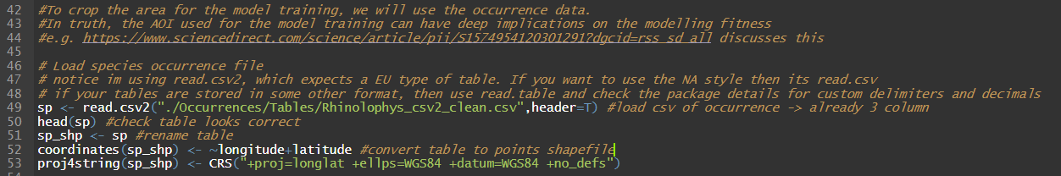

* + There are thousands of coordinate systems, but you can look up for their details and how to use them in various programming languages in webpages such as the [spatialreference.org](https://spatialreference.org/ref/epsg/wgs-84/)

The operation executed on the previous code snippet is **NOT A REPROJECTION**. It simply defines the projection of the object sp_shp in R. If you define the wrong projection, the object will not be plotted in the correct location.

* We can now explore how our data looks like using R and check if everything is in place:

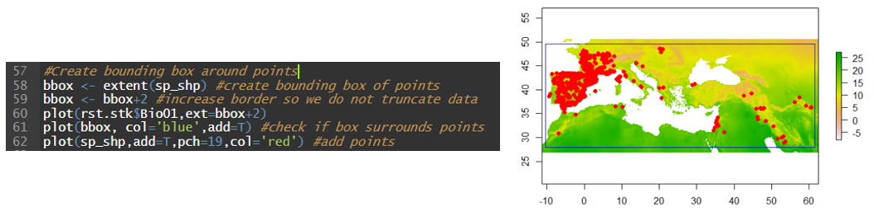

* The above code snippet only plots the data, it did not alter or change anything about it. To crop/clip the image we need to use the next code snippet:

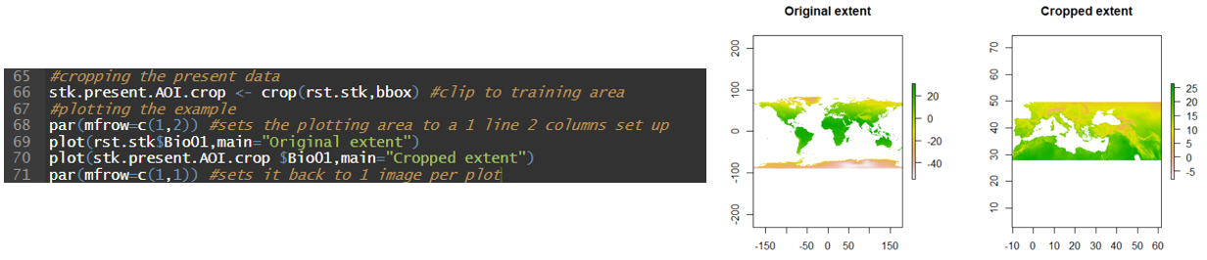

* Adapting the above function to the future scenarios is then obvious:



The last step is to save everything to the folders we have previously created. If you have multiple scenarios, you must adapt the next code snippet.

**MAXENT uses the LAST subfolder to name its models outputs.** Make sure to give a different subfolder name for each different scenario. If you do not do this, MAXENT will overwrite the output files.

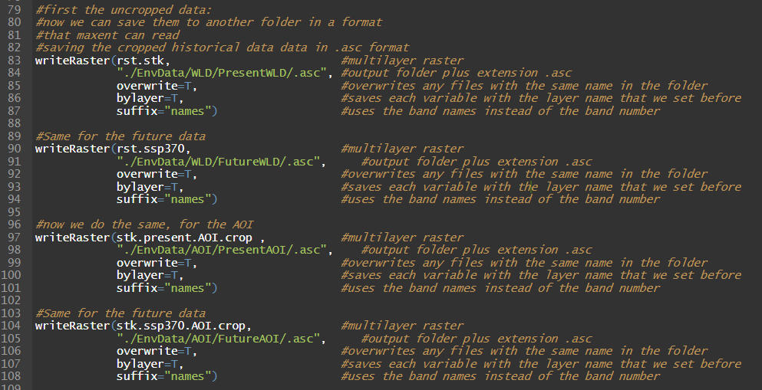

* The [writeRaster](https://www.rdocumentation.org/packages/raster/versions/3.4-5/topics/writeRaster) function will take some time, especially if you have multiple scenarios and you are using global datasets. Wait for it to finish before proceeding. Perhaps you can read about [Spearman’s rank correlation](https://en.wikipedia.org/wiki/Spearman%27s_rank_correlation_coefficient) and [Variance of inflation factor](https://en.wikipedia.org/wiki/Variance_inflation_factor) meanwhile.

Before running the script above, confirm all folders exist and are in the proper place. And confirm the paths you give in the [writeRaster](https://www.rdocumentation.org/packages/raster/versions/3.4-5/topics/writeRaster) command is correct.

You can also do these steps in a GIS but, it is more work than a simple R script and more error prone. Also notice that a simple script makes it easier to also detect where errors might have occurred.

## Selecting environmental variables

As you saw on the previous section, there are multiple choices we can use to train our model. Most models in species distribution models do not automatically select the variables for you and when they do, they do not use any specific ecological knowledge but computational or statistical methods.

**From an ecologist perspective, this does not make any sense. The first criteria must always be based on what we know of a species from an ecological perspective**. After that first pre-selection is made, there are several statistical tests we can use to evaluate if the variables we selected are correlated and potentially affecting the model.

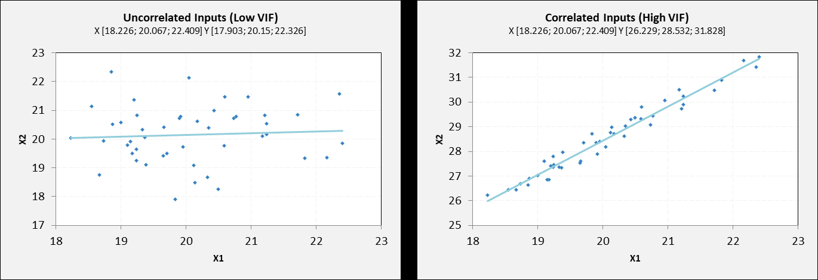

Here we will only use two specific tests: [*Spearman’s rank correlation coefficient*](https://en.wikipedia.org/wiki/Spearman%27s_rank_correlation_coefficient) *(r)*; and the [*Variance Inflation Factor*](https://en.wikipedia.org/wiki/Variance_inflation_factor) *(VIF)*. **The R code script for this section is 02_VariableSelection.R**

* **Spearman’s rank correlation coefficient: r**
  + Measures the statistical association or dependence between two variables. It is a nonparametric since we have no reason to expect any normality on the environmental data.

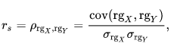

* + The test will be executed by successively comparing each environmental variable against one of all the other variables – we will call it Pairwise for simplicity sake although it is not a true pairwise test.
  + If r > 0.5, then you have high degree of correlation.
    - **As a rule of thumb, we consider that a variable is problematic if r is bigger than 0.7**
  + Another interpretation of this correlation coefficient is to consider how much association exists between variable X and Y. If this association is too high, then, in the context of SDM, it is also hard to explain which of the variables is contributing for the distribution of the species since both have the same explanatory relationship. Besides, potentially negatively affecting MAXENT predictions.
* **Variance Inflation Factor (VIF)**
  + Measures the statistical dependence of a variable X to a combination of N other variables – so – how the model correlation affects X variable in the given model with N variables. It also quantifies the severity of multicollinearity for a ordinary least squares regression

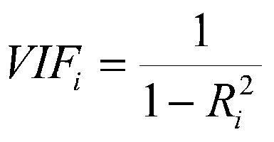

* + If you have variables X1, X2, X3,…. Xn, that you will use in the model, then the VIF is calculated for each variable:
    - VIF (X1): X1 ~ X2 +X3 + … + Xn
    - VIF (X2): X2 ~ X1 +X3 + … + Xn
    - …..
  + The R2 in each case is the R2 of the multilinear regression using all variables except for the target variable that is being tested
  + **The rule of thumb in the VIF value is: VIF > 10 implies a model structure that is highly correlated and that it likely will affect the model performance.** 
    - If a high number of variables selected have high pairwise correlation, then, it is likely that the VIF will be high as well!
* **Variables and area of interest:**
  + Historical data is provided as multiple rasters where each is one of the bioclimatic variables
  + The Spearman’s rank correlation (r) and VIF tests should both be done using the area of interest and not the entire global data. (unless your species has a global distribution).
* **Statistical criteria:**
  + Test all the pairwise correlations between the variables of interest
    - If there is no r-pairwise correlation > 0.7
      * Do not remove any variable & confirm VIF < 10
    - If one or more r-pairwise correlations > 0.7
      * If VIF > 10
        + Remove one of the correlated variables

Consider the ecological significance when choosing which variable to remove -> **remember that statistically, highly correlated variables explain the same thing, but they can have different ecological meanings.**

* + - * If VIF < 10
        + **You can use this set of variables and proceed with the analysis**

PS: if VIF is very close to 10, you can still consider removing variables, it is up to you.

**Very important:**

**Autocorrelation testing (r and VIF) are important only for the areas where the model is trained (meaning, the cropped area of interest data).** This is because global correlations between climate variables might NOT exist at a local scale and, otherwise, local correlations between climate variables might exist NOT exist at a global scale. Your model will only use the data made available in the AOI during training, so what happens in the AOI will affect the model.

Furthermore, autocorrelation effects on the predicted dataset (e.g. scenarios) do NOT affect the model training either. This means, that **correlation analysis does NOT have to be performed on the target dataset**.

And lastly, these statistical tests test two different aspects of variable and model correlation. A simple understanding of correlation is that if Variable X is highly associated with Variable Y, then you can predict the values of Y using variable X. This means that when you use them together **1) it is hard to interpret which variable is responsible for a specific output and 2) models tend to overfit the more easily.**

**In your case:**

* + Which variables are ecologically significant for the species?
    - Base your decision on what you already know about the species
    - Make a list of potential variables that have more significance
      * Then use the statistical tests to verify that you can use them on your model
    - **Explain the reasoning for selecting the variables and describe which of these variables were excluded (or not) on the report**
  + **Use this set of N hypothetical bioclimatic environmental variables which are related to the species physiology for the next step by step test of spearman’s r correlation and VIF to confirm (or not) that you can use this pre-selection.** 
    - The result of these step is also a more “parsimonious” model which uses the most data possible without negatively affecting the model.

**Testing Spearman’s rank correlation:**

* In my case, the first selection was:
  + Bio 01 – Mean annual temperature
  + Bio 04 – Temperature seasonality
  + Bio 07 – Temperature Annual range
  + Bio 12 – Annual precipitation
  + Bio 15 – Precipitation seasonality
  + Bio 19 – Precipitation of the coldest quarter

Then, I performed a **Pairwise spearman’s R correlation** test: (remember: **02_VariableSelection.R)**

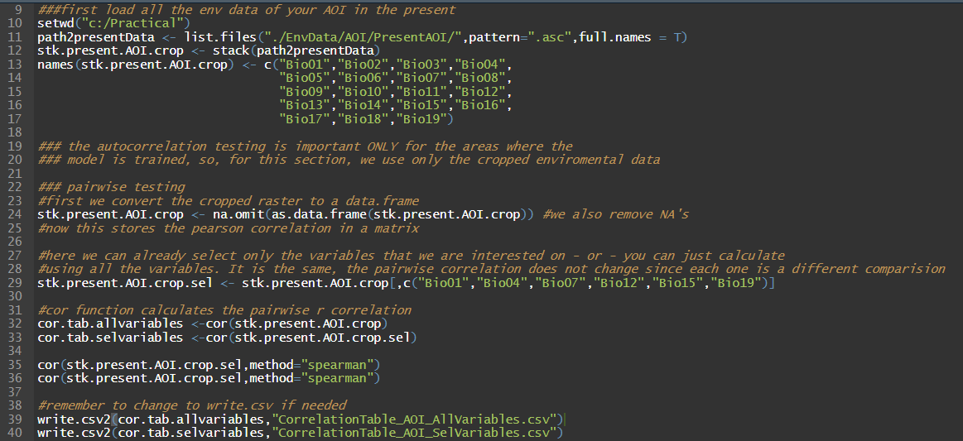

* + This short script starts by loading the rasters from the AOI folder (lines 11 and 12)
  + Renames them (lines 13)
  + Converts them to a R dataframe object (line 24).
    - It also removes all “Not Available” (na) values. These are places where there is no values in the raster, e.g. the water areas.
  + Uses the [cor function](https://www.rdocumentation.org/packages/stats/versions/3.6.2/topics/cor) of R (line 32, 33) to calculate the pairwise correlation (in-built function).
  + Saves the results, to two different tables: one considering only the selected variables (above) and one using all the 19 bioclimatic variables. Either is fine since the pairwise correlation **does NOT change when you remove variables**. But its easier to explore a smaller table.
  + The pairwise correlations can then be more easily investigated using Excel
* Open the file: “CorrelationTable_AOI_SeVariables.csv” in Excel

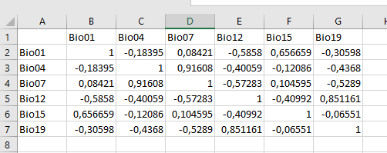

* + Highlight the content of the table - > Styles section -> Conditional Formatting - > highlight cells rules -> Larger than 0.7
    - Also highlight negative correlations: less than -0.7 in different colour if you like.

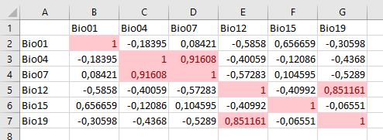

* + In my case, there are two pairwise correlations > 0.7
    - Bio07~Bio04
    - Bio19~Bio12
  + We can use test the VIF now to see if my model is ok even considering these two correlations
* **Testing multicollinearity using VIF:**
  + Its trivial to do by hand, but, extremely repetitive and prone to error. Luckily we can use the vif function in the [USDM](https://cran.r-project.org/web/packages/usdm/usdm.pdf) package

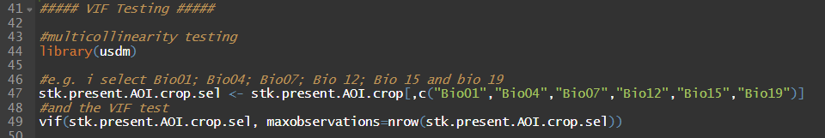

* + Inputs of vif function:
    - Target dataframe
    - Number of observations to be used (if less than the total number, them it will use a sample of the data frame)

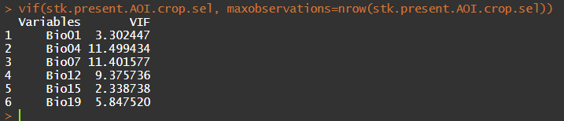

* + This implies that either Bio07 or Bio 04 must be removed.
    - I opted to remove Bio07 – The mean temperature range since I already have enough variables related with temperature.

The pairwise correlation does not have to be tested again since it does not change when variables are removed. **But the VIF must be recalculated every time a variable is removed since we removed variables from the model**. In your report we expect that you state all intermediate VIF results and not just the final model, so we can understand your reasoning when removing variables.



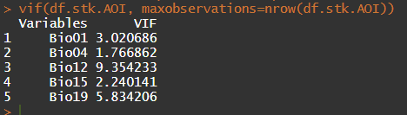

**We finally have everything set up (almost) to maxent!**

# Checklist before MAXENT:

**Regarding the occurrence data:**

* Is the Occurrence data in a .csv or .txt file format in NA style?
* Are the fields on the table in the correct order: species, longitude, latitude?
* Do I have only one species name in the column species?
* Do I have only numbers in the column’s longitude and latitude?
* Do I have missing data on the table?

**Regarding the Environmental data:**

* Do I have a list of the selected variables?
* Are the variables saved in .asc format?
* Are they saved to different folders where each last subfolder has a unique name?
  + Does the data inside of each subfolder have the same names? (They should!)

**Have you downloaded MAXENT?**

Latest version: <https://biodiversityinformatics.amnh.org/open_source/maxent/>

Version 3.4.1: [downloadlink](https://drive.google.com/drive/folders/1PDgiSTDSgKweZUMAgdNxU2jQ11E7ImIk)

* I had problems running the latest version of MAXENT. The problem I had, is detailed later. Download this earlier version just in case you have the same problem later.

**MAXENT requires JAVA to be installed in the computer to run. Do I have it?**

<https://www.java.com/en/download/help/download_options.xml>

Confirming if JAVA is installed (Windows): (you can find how to do this in other operating systems on the internet).

* Open a command line window (use the search option on the bottom left)
* Type: “java -version” and you should see the following response:

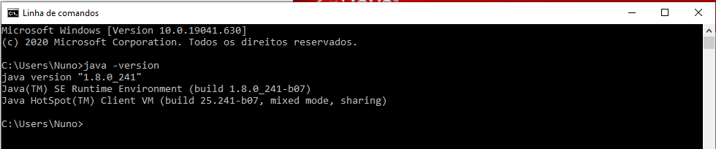

# MAXENT – Maximum Entropy Modelling:

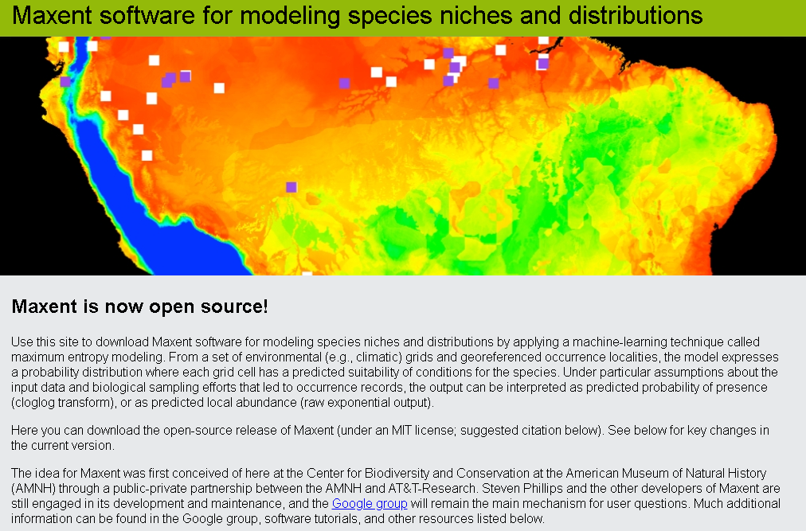

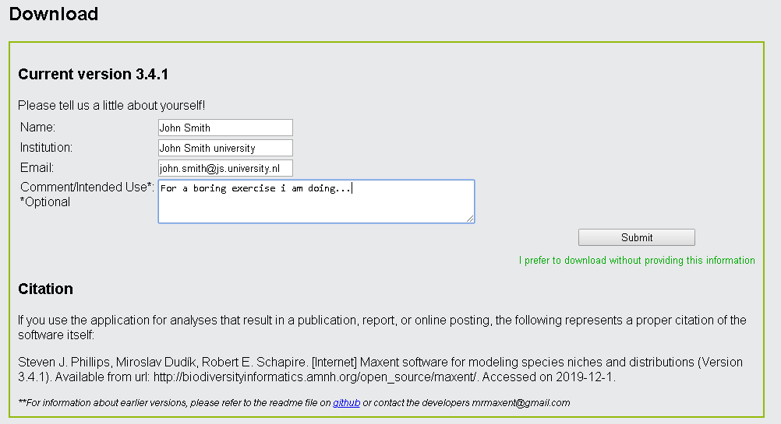

## MAXENT Intro:

This small intro aims to give a quick intro to MAXENT, its main ideas and some of its recent history. In terms of SDM what we are wanting to know is the **probability (π)** of **Presence (P)** of a species given the observation of some **Environmental factors (E)**, aka Bayes theorem:

$$π\left(P | E\right)=\frac{π(E|P)∙π(P)}{π(E)}$$

We can achieve this by different method, but the one MAXENT uses is based on the [maximum entropy principle](https://en.wikipedia.org/wiki/Principle_of_maximum_entropy). This principle is based on the premise that when estimating any probability distribution, you should select the one that is most uncertain - initially proposed by [E. T. Jaynes](https://en.wikipedia.org/wiki/Edwin_Thompson_Jaynes) in 1957 for thermodynamics. **Entropy is a measure for disorde**r: When you flip a coin for which the π(head) = π(tail)=0.5, then the outcome of each toss is hard to predict and therefore has a high entropy. But if it is a biased coin where the probability for head is almost 1, then the unpredictability of the outcome shifts towards a clear expectation for head, and so the entropy decreases. If we plot a coin toss case, the highest uncertainty relative to the results would occur when the coin is unbiased:

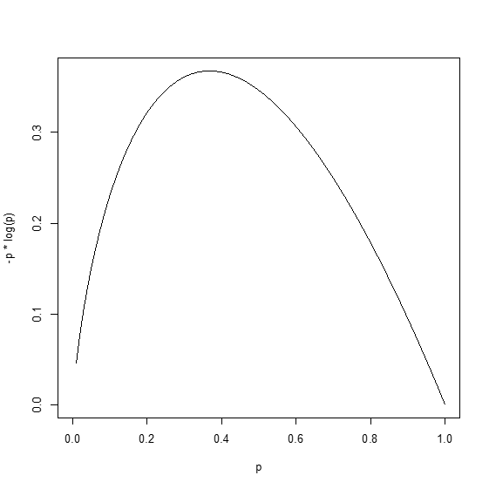

Multiple metrics exist for measuring it, but MAXENT uses the commonly used Shannon Information Entropy which measures the contribution of each possible outcome of a variable to the overall entropy in relation to the probability of these outcomes.

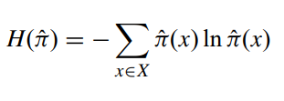

Cool, now in terms of Machine learning from all the possible distribution that fit our constrains, **we need to find the one that maximizes the entropy.** This is achieved by minimizing the [relative entropy](https://en.wikipedia.org/wiki/Relative_entropy) (RE) between two distributions: one that is defined in function of our observations and one uniform distribution (everything has the same probability);

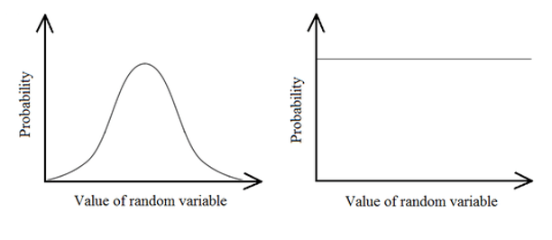

In Phillips, ([2004](http://rob.schapire.net/papers/maxent_icml.pdf), [2006](https://www.sciencedirect.com/science/article/abs/pii/S030438000500267X)) this is described as minimizing the **relative entropy (RE)** between an observed **probability π-tilde** and the a **Gibbs distribution (qλ)** that fits the observations (plus some weighter regularization parameters to avoid overfitting):

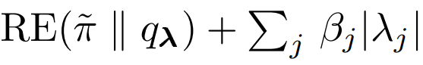

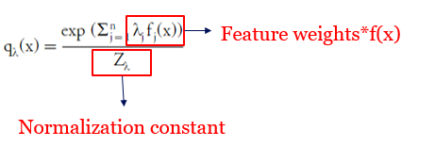

And these are the parameters (feature weights) that the machine learning procedure will try to change each parameter individually until it finds the best solution (using a [sequential-algorithm](https://link.springer.com/article/10.1023/A:1013912006537) for searching the solution space).

**But what does this all mean?!?!**

What this means for the species distribution models is that probability of occurrence is given by the conditional probability of a given set of presence observations against the distribution of the “random background” or, basically, if the distribution of the species was random: (figure adapted from [Elith, 2010](https://onlinelibrary.wiley.com/doi/full/10.1111/j.1472-4642.2010.00725.x)). **Notice that the *Environmental probability density* is obtained by the “Background points” and the final presence density function is the one that “maximizes” their similarity (MAXENT) by minimizing their difference (aka relative entropy) through tweaking the parameters that define the Gibbs distribution.**

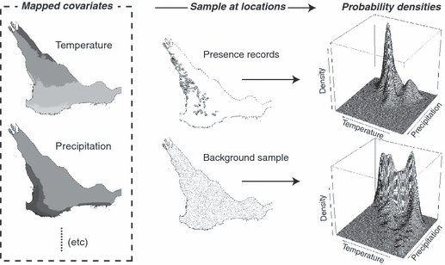

But it also means that even if MAXENT aims to find the most uncertain model that fits the constraints (occurrence data), still, any model that you train with MAXENT will be constrained by the real observations of the species. Therefore, it is important to consider if the occurrence data indeed reflects the ecological niche of the species and how reasonable is it to extrapolate (in the environmental space) to ranges where you have no information available at all. This is one of the core problems in all cases of machine learning: “unseen” examples.

The big growth of MAXENT being used in Species Distribution Models started when [Phillips, 2006](https://www.sciencedirect.com/science/article/abs/pii/S030438000500267X) made his seminal publication on the topic and when the Java utility that is used in this tutorial was made available. Only recently, this software has been made open source and recently there has been some debate about the nature of the algorithm. [Renner, 2013](https://pubmed.ncbi.nlm.nih.gov/23379623/) showed that MAXENT as applied in SDM was a particular case of Poisson Regression Models which lead to a number of changes on how the model is used and provided a number of options to address some of the more challenges in MAXENT SDM modelling (see Table 1 in Renner).

So now, not only the Java code was made fully open source but also MAXENT was coded in R on [maxnet package](https://cran.r-project.org/web/packages/maxnet/index.html) albeit with some limitations in terms of the visualizations and outputs produced. Most importantly, the possibility of using Poisson regressions to implement the model, implies that everything can be done using standard R packages (which we will not do today!). Opportunities and its implications on this topic are further discussed in [Phillips, 2017](https://onlinelibrary.wiley.com/doi/full/10.1111/ecog.03049), by the original authors of MAXENT.

Deeper explanations on MAXENT and how it works and how it is adapted for SDM are beyond the scope of this class. But feel free to investigate more about it:

* Simon DeDeo ([Complexity Explorer channel](https://www.youtube.com/watch?v=6YEn9QRy3ks&list=PLF0b3ThojznT3olRuplp5x41wUp_LZxHL&index=1&ab_channel=ComplexityExplorer)) (not applied to ecology)
* John Harte (Stanford) - [Talk on Maximum Entropy in Ecology complexity](https://www.youtube.com/watch?v=XElfPKCG69o&ab_channel=StanfordComplexityGroup)
* Phillips - [2004](http://rob.schapire.net/papers/maxent_icml.pdf); [2006](https://www.sciencedirect.com/science/article/abs/pii/S030438000500267X); [2017](https://onlinelibrary.wiley.com/doi/full/10.1111/ecog.03049) -> original MAXENT papers in SDM
* A brief tutorial on [MAXENT](https://biodiversityinformatics.amnh.org/open_source/maxent/Maxent_tutorial2017.pdf)
* Various: [(1)](https://onlinelibrary.wiley.com/doi/full/10.1111/jbi.12227) ; [(2)](https://onlinelibrary.wiley.com/doi/pdf/10.1111/j.1600-0587.2013.07872.x); [(3)](https://onlinelibrary.wiley.com/doi/pdf/10.1111/j.1472-4642.2010.00725.x) -> **Highly recommended for ecologists and potentially very useful for your reports.**

## Setting up MAXENT:

* Open the MAXENT software
  + Use the executable jar file (.bat)
* Load your occurrence data
* Load the training environmental layers (the ones cropped to the AOI).
* **You should now see this:**

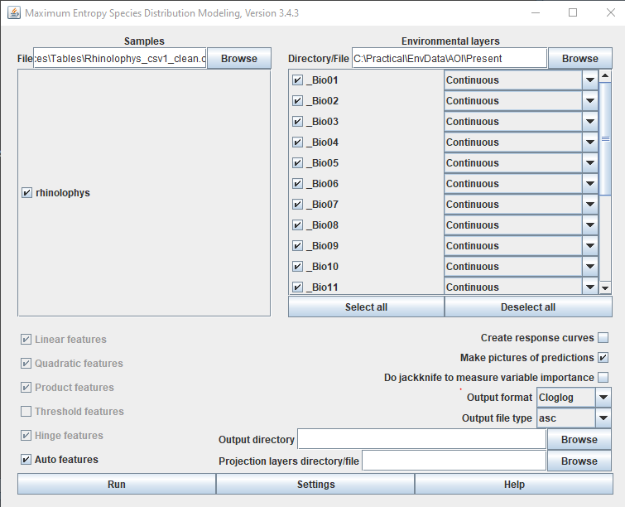

* **On the menu on the right**, select only the variables that were identified before:
  + in the case of this tutorial: Bio01, Bio04, Bio12, Bio15, Bio19
* **Options on the main menu**
  + Auto-features: On
  + Create response curves: On
  + Make pictures of predictions: On
  + Do jacknife to measure variable importance: On
  + Output format: Logistic
  + Output file type: asc
  + **Output directory:**
    - C:\Practical\Maxent\EXP01 **(ADAPT TO YOUR CASE)**
    - Maxent produces a lot of outputs so it advised to have different folders for different runs as you try out the software.
  + **Projection layers directory/file**
    - This is where you add the paths to your scenarios or world data
    - Maxent allows you to add all the paths at once, separated by a comma (which is handy because otherwise you would have to do one by one)
    - **In my case, given where my files are:**

C:\Practical\EnvData\WLD\PresentWLD, C:\Practical\EnvData\AOI\FutureAOI, C:\Practical\EnvData\WLD\FutureWLD

* **The main menu of MAXENT should now look like:**

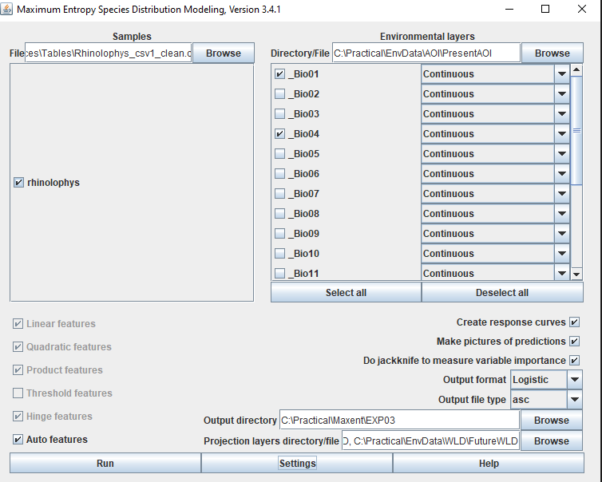

* Select “Settings” and then Basic.
  + Set the Basic menu the same as this:

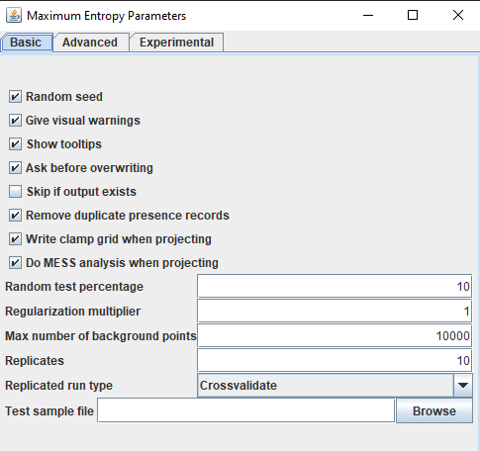

* **Basic Menu:**
  + Notice the number of replicates:
    - The number of replicates is the number of times maxent repeats the entire process. The more “the better”. **Your final result on the report should consider at least 10 replicates.**
    - It’s recommended though, that first time you run the model, you are more concerned to check if everything is running properly, so , feel free to run a smaller number of replicates, e.g. 3 or 4.
* Set the Advanced section like this:

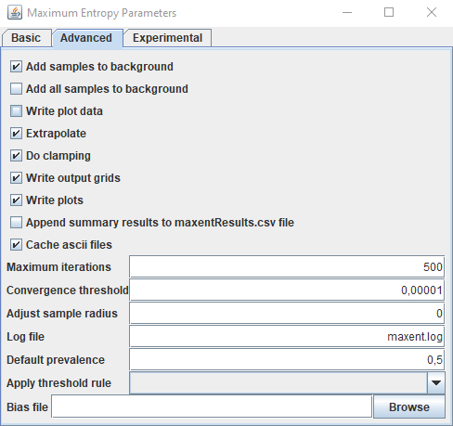

* For you to investigate:
  + What is the impact of the “extrapolate” and “do clamping”?
    - [Hint 1](https://biodiversityinformatics.amnh.org/open_source/maxent/Maxent_tutorial2017.pdf) & [hint 2](https://onlinelibrary.wiley.com/doi/10.1111/j.1600-0587.2013.07872.x)
    - What is the best option for your case?
    - You can discuss this on your report or with us during the exercise.
* **The “Experimental” section it should look like:**

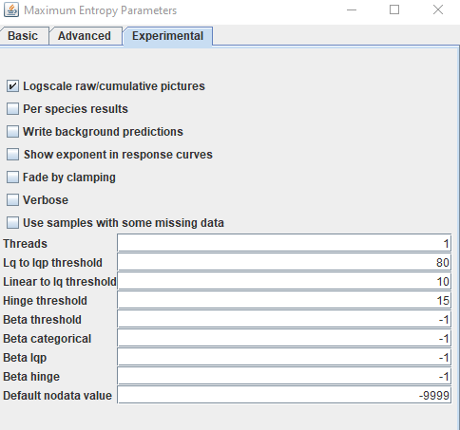

Most of these options are general options (per species results, threads, etc) but some are related to the inner workings of the model. **The Threads option refers to the number of cores you want to use for the calculation -> the more the faster,** but it might slow down your computer. Choose whichever number of cores you are comfortable with.

**Notice the “Fade by clamping” option**. This relates with the clamping options on the advanced section. Investigating what it does might be interesting and something you can consider looking at for your report.

**When all these options are done, go back to the main section and press “Run”. And wait.**

## MAXENT – Common warnings & errors messages:

**Common warnings: Missing data or repeated/overlapping occurrences**

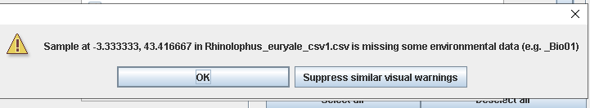

This message is telling that some of the environmental data is missing. This can be for many reasons, perhaps the points fall outside the map area or perhaps the point falls into a pixel/cell that is empty (eg. Water). Ignore these messages and if the process continues running it means you are ok to go.

**Another notification** you might get is that some occurrence is overlapped with another. This happens because maxent only considers one occurrence per pixel/cell and you can have multiple occurrences of a species within a 10 by 10 km cell. Ignore this warning, and proceed, it should be fine.

Do notice that if at any point you georeferenced the data incorrectly, both these problems will become serious. **In my case, I also had a serious problem:**

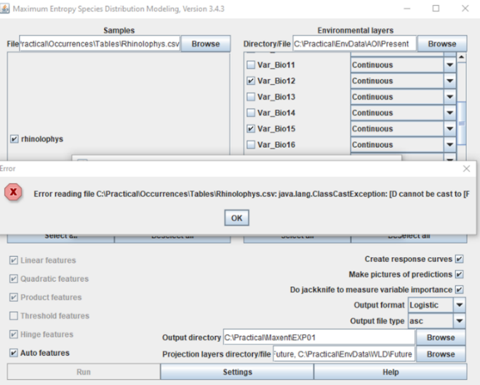

This seems to be a problem with the latest version of maxent and my Java installation. It is common for these things to happen with older software or when new version of Java is launched. My solution was to use an older version that I had which worked fine. Find his older version [here](https://drive.google.com/drive/folders/1PDgiSTDSgKweZUMAgdNxU2jQ11E7ImIk).

# Validating Species Distribution Models:

Species distribution models from a machine learning perspective supervised learning binary classification exercise. What this means is that the accuracy is generally measured in function of a [confusion matrix](https://en.wikipedia.org/wiki/Confusion_matrix) that summarizes the numbers of hits/and misses.

|  |  |  |
| --- | --- | --- |
|  | Reference | |
|  |
| Predicted | True positives | False Positives |
|  |
| False negatives | True negatives |  |
|  |

True Positives (TP) are all the predicted presences that were indeed Present in the reference data, while False Negatives (FP) are predicted absences that were indeed absent in the reference data. False negatives (FP) are Type II error, they are predicted absences where the species is found to be present in the reference data. False positives (FP) are Type I errors, meaning, locations where the model predicted the presence of the species, but it was absent. From here, you can calculate the amount of times you model made different mistakes and by exploring different relationships in the confusion matrix, you can explore specific abilities of your model:

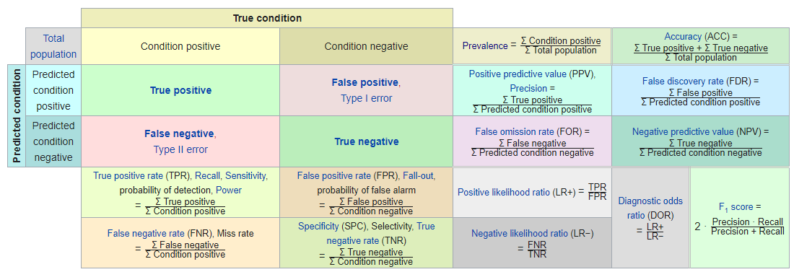

This is very important for different sciences. **For example, in medicine when you want to predict if someone is infected with a highly contagious virus there are less consequences for committing Type I errors than Type II errors.** So, you will accept models that minimize Type I errors even at the cost of increased Type II errors. Helps to understand why during the Covid19 outbreak some central health services choose to not even test people who accuse light to mild symptoms and instead just advise them to stay home.

From this confusion matrix, more advanced approaches can be created. For example, if we want to know how well a model is able to distinguish the target class from the rest, we can use the [Area under the curve of the Receiver operating characteristic](https://en.wikipedia.org/wiki/Receiver_operating_characteristic) (AUC-ROC) ([Fielding and Bell 1997](https://www.cambridge.org/core/journals/environmental-conservation/article/review-of-methods-for-the-assessment-of-prediction-errors-in-conservation-presenceabsence-models/FFA0880CE3C3591A5906B83C04727F46), [McPherson et al. 2004](https://besjournals.onlinelibrary.wiley.com/doi/full/10.1111/j.0021-8901.2004.00943.x), [Raes and ter Steege 2007](https://onlinelibrary.wiley.com/doi/10.1111/j.2007.0906-7590.05041.x)). This curve is built by considering an increasing value for the threshold and plotting its TPR on the y axis and the FPR on the x axis. These quantities relate with sensitivity and specificity which are measures of your model’s ability to predict true positives (Sensitivity) and predict true negatives (Specificity):

$$\begin{matrix}TPR=Sensitivity= \frac{TP}{FN+TP} \\ FPR=1-Specificity=1- \frac{TN}{FP+TN}\end{matrix}$$

The curve then has two characteristics: first, both TPR and FPR vary from 0 to 1 and also this relation gives also an indication of how well it can separate the true positives from true negatives, meaning, the ability to discriminate the target from the background:

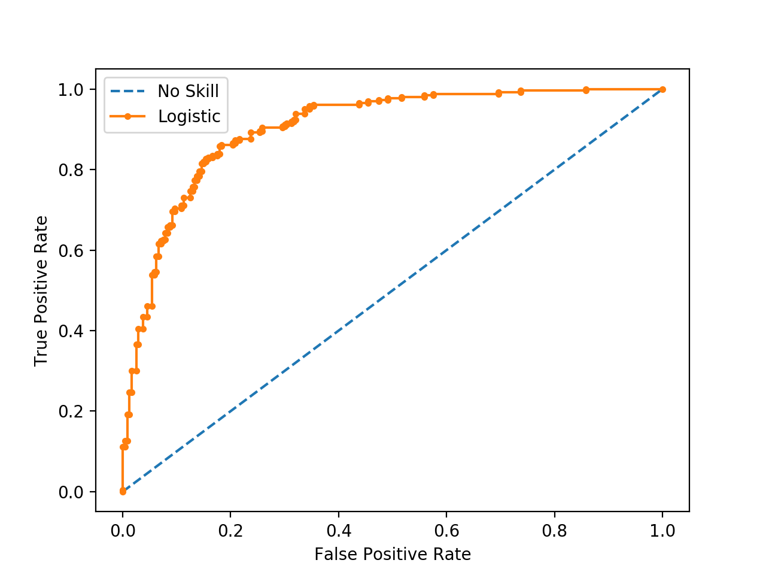

**This curve is known as the “*Receiver operating characteristic*” (ROC). The *Area under the curve* (AUC) is the integral of the area of the ROC curve. If your model has absolute power to discriminate the two classes, then AUC = 1 (notice that TPR and FPR range from 0 to 1 only, so it’s a square with side 1). If your model has AUC = 0.5 it means the model is no better than random at predicting the species, then, your AUC is equal to the area of the triangle along the blue line in the figure above (0.5* 1 = 0.5). So AUC varies from [0 to 1] – but generally, from 0.5 to 1 only since below 0.5 means you are worse than random, so your model is actually doing the opposite of what it should!**

There is a known problem regarding AUC, which is that it is highly affected by prevalence. Prevalence is the fraction of positive cases against the total number of possible cases. Meaning, how common something is. It has been shown that the maximum possible AUC is given in function of:

$$\begin{matrix}maxAUC= 1- \frac{a}{2} \\ a-prevalance\end{matrix}$$

**In terms of species distribution modelling, this means that if your species is a generalist within your area of interest, then, your maximum AUC will be lower,** thus, at some point, would not be able to design any model that is able to discriminate the species. This might sound not obvious, but, basically what the model is saying is that at some point the random process guiding the distribution is no longer related to your predictor variables. And this can be understood and visualized on next figures

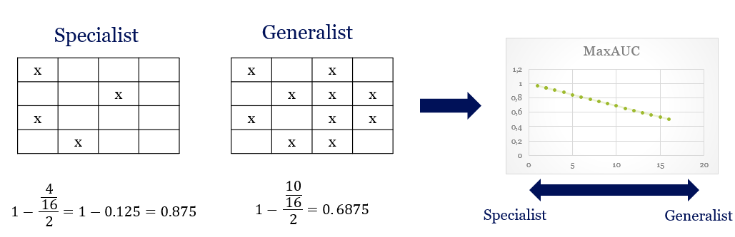

Which we can translate into a GIS view:

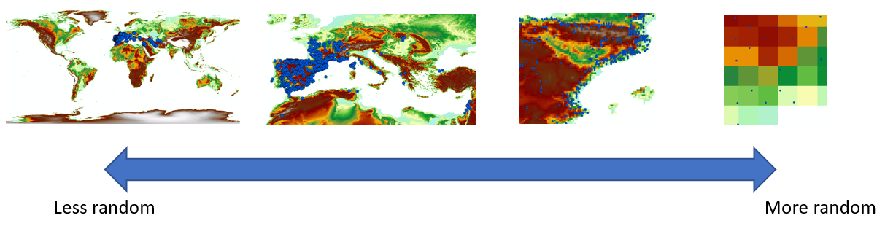

The implication here is that at “broader” scales you are witnessing different processes designing the distribution of the species and at some point, there will no way (or at least, not with the resolution we have for both types of data) to distinguish patterns in the data. The obvious outcome of a model trained with a “random” input is a model that produces random outputs.

You can think of this on your real life: you know different species of tree’s exist in the Netherlands so your model should be able to predict that. But, if you want to know which trees are where, well some species can survive in the Netherlands and other are not due to climate. But you also know, some species used by humans near the road for aesthetics and green urbanization and other are planted in forest, so the process defining the actual local distribution is manmade, so: if you want to model a specific distribution of a tree in the Netherlands you would need to include information that relates somehow to human activity.

**Now, how to interpret this in terms of species distributions? Well, generalist species occupy broader areas and therefore it will be naturally harder to discriminate the reasons why they occupy those areas (maxAUX is smaller). In the case of specialist species, it is the opposite, it is easier to discriminate them (maxAUC is closer to 1). You should therefore interpret your AUC in function of the original distribution of your data within the training area, aka the area of interest.**

Now, in terms of MAXENT you will have by now noticed that it does not use or need or have, absence data. Therefore, it can’t actually calculate the true AUC-ROC. Instead, FPR is calculated using the fractional predicted area and the TPR is calculated using the false omission rate, meaning, it uses the actual predictions of the model to estimate AUC ([Phillips et al, 2005](https://www.cs.princeton.edu/~schapire/papers/ecolmod.pdf)):

$$\begin{matrix}{TPR}_{maxent}=1-A_{FOR}=1-\frac{A_{FN}}{A_{FN}+A_{TN}} \\ {FPR}_{maxent}=1-A_{PPV} =1-\frac{A_{TP}}{A_{TP}+A_{FP}}\end{matrix}$$

Which therefore is instead showing a AUC curve based on solely on the areas of FOR (False omission rates) and Positive Predictive-value (PPV) based on the data left out for validation by the model (composed of Presences and pseudo-absences generated as background data).

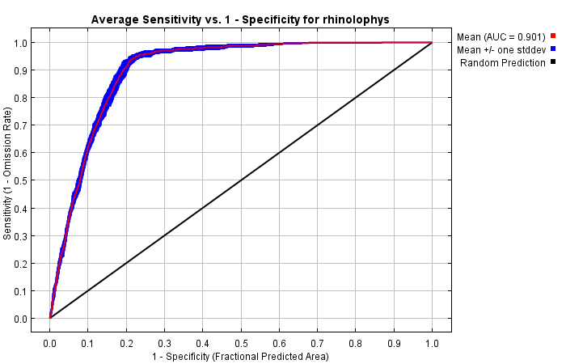

This is the main validation tool available on MAXENT which provides a ratio between errors of omission and errors of commission and is equally affected by the prevalence of the data like the regular AUC value.

More info about these topics on [this manual](https://www.amnh.org/content/download/141368/2285424/file/LinC3_SpeciesDistModeling.pdf) and oriented to ecologist in [Elith et al, 2010](https://web.stanford.edu/~hastie/Papers/maxent_explained.pdf) and throughout the extensive scientific literature that used MAXENT.

Other than AUC, MAXENT provides some other methods for “exploring” your results which give extra information regarding how well you can trust your model in space and time. These methods are discussed later in the manual as they to not produce an actual “final” estimate of the error you are possibly committing but are more exploratory tools.

## Interpreting MAXENT report & outputs:

* Open your maxent/Results folder and investigate

You will find an .html file/s that summarize your results and includes the AUC evaluation. If you have repetitions, there is one html file per repetition, and one that summarizes the results of each replicate, reporting means and standard deviations.

**The folder also contains ascii files which you can open in ArcGIS, png files, and other separate files.** It is important to note though, that these ascii files do not carry projection information with them and therefore, ArcGIS or QGIS will warn you that there is no projection system. You know though, that the data is in WGS84

**On the report file, notice your first and second graphic:** 1) Average omission and predicted area for the modelled species and 2) AUC value (second graphic – AUC-ROC).

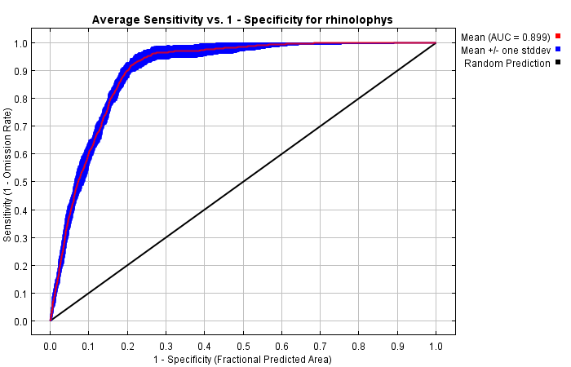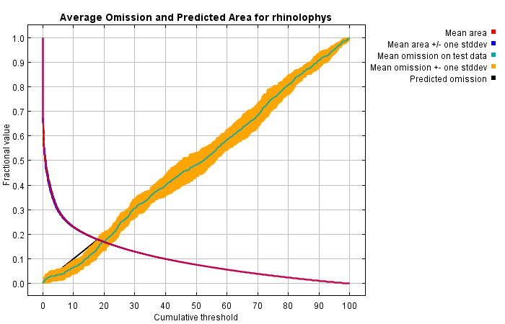

The graphic on the left shows how the predicted area of presence changes in function of the threshold (green arrow)**.** When the th >= 0, then the entire map predicted presence, therefore, fractional area = 1. This helps to understand if your model is on the risk of overestimating presences. The second arrow (red) points at the mean omission error overlapping the predicted omission –> meaning, the omission predicted on the cross validation of the training data and omission predicted on the test data.

On the right graphic, it is the AUC-ROC curve. Notice, it is based on the variations in areas and not real presence/absence validation data. According to [Mandrekar, 2010](https://www.sciencedirect.com/science/article/pii/S1556086415306043):

* + AUC ~ 0.5 -> No “better” than random
  + 0.7 > AUC ≤ 0.8 -> Acceptable
  + 0.8 > AUC ≤ 0.9 -> Excellent
  + AUC > 0.9 -> Outstanding

**Remember though, that, prevalence would affect this standard interval and in our case, we do not have a precise distribution of the species. If we had, we would not need to model it. So, you have to interpret this in the context of your species distribution.**

But this result must often be interpreted in function of how “generalist” or “specialist” your species is. Generalist species occupy broader areas so they are more prevalent and as explained in the pink box before and [Phillips et al. 2006](https://www.sciencedirect.com/science/article/abs/pii/S030438000500267X), the maximum AUC is 1-a/2 where a is the total fraction of the area occupied by the species.

What this implies is that for generalist species you do not necessarily expect high AUC for accurate models whilst for specialist species you should expect very high AUC for accurate models. **Please consider this when discussing if your AUC was “good” or “bad”.**

**In the “Pictures of the model” section** - you see the probability of occurrence within each pixel and the output of the different scenarios in the order you submitted them.

* Maxent reports the mean probability (left) and its standard deviation (right) of all the replicates you ran
* The layers are in your main results folder also:
  + E.g. Species_avg.asc ; species_scenarion_avg.asc
  + And they can also be explored in a GIS or opened in R. These are normal .asc format rasters that you can use for further analysis
  + Furthermore, you also have .asc files of each individual run.

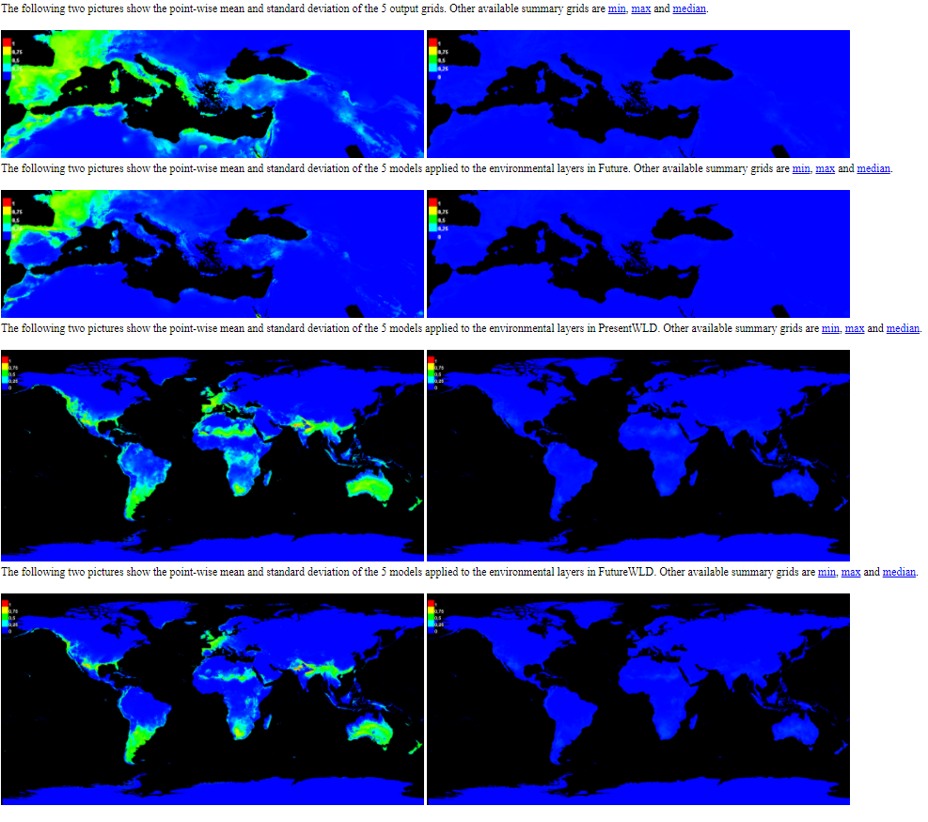

* **In the Response curves section:**
  + You have the “response” curves of the species probability in function of the values in each variable.
    - Keeping all variables at their mean value except for the target value:

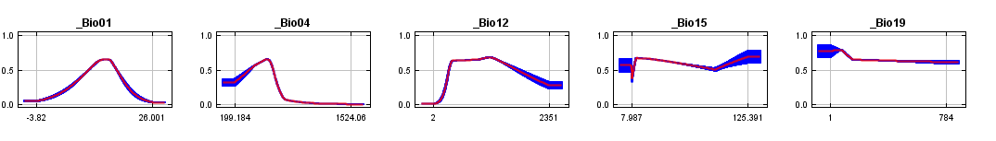

* + - While predicting using only target value

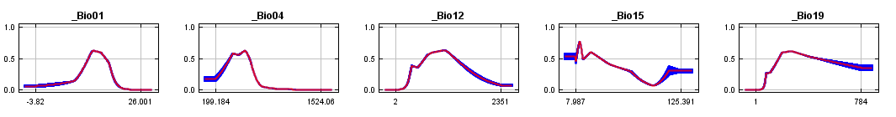

* + This is very helpful to identify many things:
    - **Identify ranges of the values that correlate highly with the presence** of the species (e.g. Bio01, approximately around 15 mean annual temperature) (eyeballing)
    - **Correlations between variables** (if they have similar responses)
      * Bio01, Bio04 seem to have a small degree of correlation
    - **Extrapolations**
      * If one variable has high probability near the maximum value, that means that if that maximum value changes in a future scenario, then the model is extrapolating beyond that range.
        + E.g. bio 19 for both cases
    - **Non-linear relationships**
      * In some case, you have a “normal” response, as in it follows a “kind of” [gaussian distribution](https://www.researchgate.net/profile/Jan_Bender/publication/334535945/figure/fig1/AS:781913300144134@1563434066572/Gaussian-bell-function-normal-distribution-N-0-s-2-with-varying-variance-s-2-For.png) while in other it behaves very weird
* **In the Analysis of Variable contributions section:**
  + Variable importance:

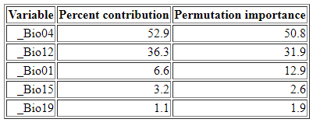

* + - Percent contribution:
      * Changes in the regularization parameters, normalized for [0 – 100]%
    - Permutation importance:
      * Changes in training AUC by excluding/including given variable, normalized [0 – 100]%
    - Most important variable: Bio04 – Temperature seasonality
    - Correlation between variables will seriously affect these results.
  + **The Jackknife test consist** of multiple tests which include or exclude a specific variable from the model. Each report how much “gain” did X variable contribute or not.
    - Training gain refers to testing during the model training phase
    - Test gain refers to tests during using the data left out for validation
    - AUC gain refers to variations on the AUC accuracy using the TEST data.

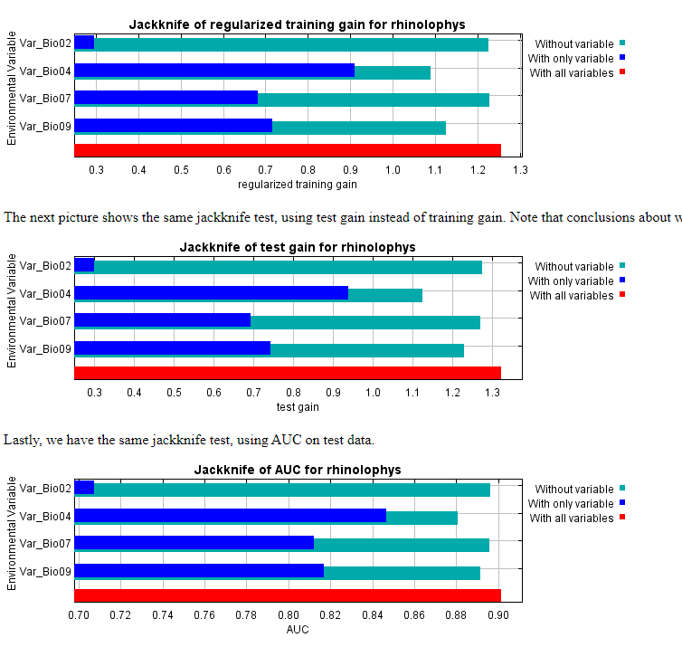

These two previous reports are usually very important for ecologists because they provide a direct hint into understanding if the model did in capture known ecological ideas about the species. In my case, Temperature Seasonality (BIO04) played the most important role in the distribution of the species. And locations with lower seasonality (look at response curves), and it makes sense, since these bats inhabit caves which help maintain a stable temperature. Locations with high levels of seasonality would imply that also the temperature in these caves would change **(I am guessing all this! I am not an ecologist).**

These are main model fitness and performance statistics that MAXENT software provides on the main page. There is other information’s worth exploring though.

**Go to one of the models, scroll to the top of the page press one of the hyperlinks, e.g [0] and explore what is there**.

While much of the information is similar, they are the results related with that specific model run, there a section in the end that is interesting:

Besides seeing the specific omission rate and AUC-ROC curve you now have a table that shows a list of thresholds. Among these, most widely used ones are: ‘10 percentile training presence’, ‘Equal training sensitivity and specificity’, and ‘Maximum training sensitivity plus specificity’

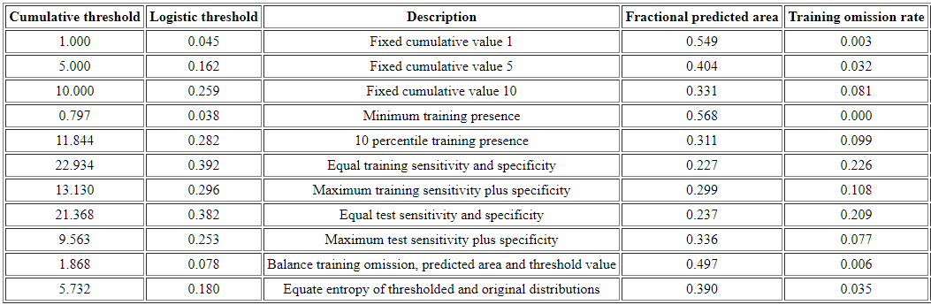

**The question here is, from what probability between 0 and 1, should we consider that the species is present?** In a classic approach, you would think that any probability above 50% is a guess better than “random”. But in truth, this probability depends on the prevalence of the species and on other factors. Therefore, selecting this threshold becomes a specific problem in SDM. **So, again, if a species is prevalent you might want to minimize your Type II error (false negative) because predicting where it is not, is harder than predicting where it is. The opposite applies for a specialist species, perhaps you want to minimize the Type I error.** If you want to “balance” the Tipe I and Tipe II errors, you can choose the “Equal test sensitivity and specificity” which generally applies for most cases.

These thresholds are related to the concept of [confusion matrix](https://en.wikipedia.org/wiki/Confusion_matrix). On the table, you have multiple options for the threshold value which maximize or minimize specific aspects of the data. Basically, what the software is doing is varying the threshold in an interval (in 0 to 1) and reporting which thresholds maximize what is described: **e.g. 0.382 ensures that your test sensitivity is equal to the specificity – which means that your model is equally likely to predict true positives (sensitivity) and true negatives (Specificity)**.

**For one of the next steps (a change detection map) you will need to set a threshold. To select the threshold value for your model:**

* Go to each different run [0][1]….[N] and take note of the “Logistic threshold” for the “Equal sensitivity and specificity” criteria.
* **Your final threshold value will be the average of all the thresholds.** 
  + **You can add this mean + standard deviation of the threshold value to your report**
* Find the picture where [Multivariate Environmental Similarity Surfaces (MESS)](https://besjournals.onlinelibrary.wiley.com/doi/10.1111/j.2041-210X.2010.00036.x) and “Most dissimilar variable” (MoD) are shown. For the formulas, see the [Appendix of Elith, 2010](https://besjournals.onlinelibrary.wiley.com/action/downloadSupplement?doi=10.1111%2Fj.2041-210X.2010.00036.x&file=MEE3_36_sm_AppendixS1-S7.pdf) page 3

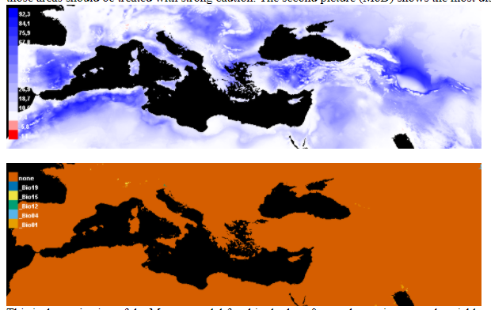

* These two results show you two specific things for the run [0] (or the one you selected)
  + Where in space there was the most difference between the data used for modelling and the data available -> **meaning the areas where you are likely extrapolating**.
  + And on the bottom, **it tells which variable is most dissimilar** – e.g. no variable is really different in the above case
* **This is VERY important when** analysing future scenarios because it tells the researcher something about the uncertainty of the predictions. The more extrapolation that exists, the more unlikely is your prediction.
  + Notice that, options like fade by clamping, extrapolate etc on the model setting will affect the above estimates.
* **MESS and MOD are also provided as .asc files and are on the main output folder of MAXENT.** How to combine them and then use them, is up to you if you want to go for the extra credit. **(PSS: averages & modes might be a simple and fair enough approach!)**

A final interesting map available on the individual report of each which provides the “absolute difference between using clamping or not using clamping” is visible in this figure:

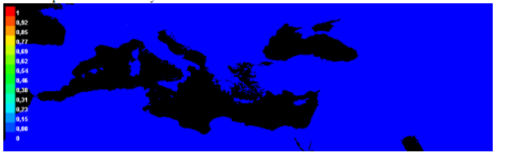

If I look the prediction to the present time and future at a global scale:

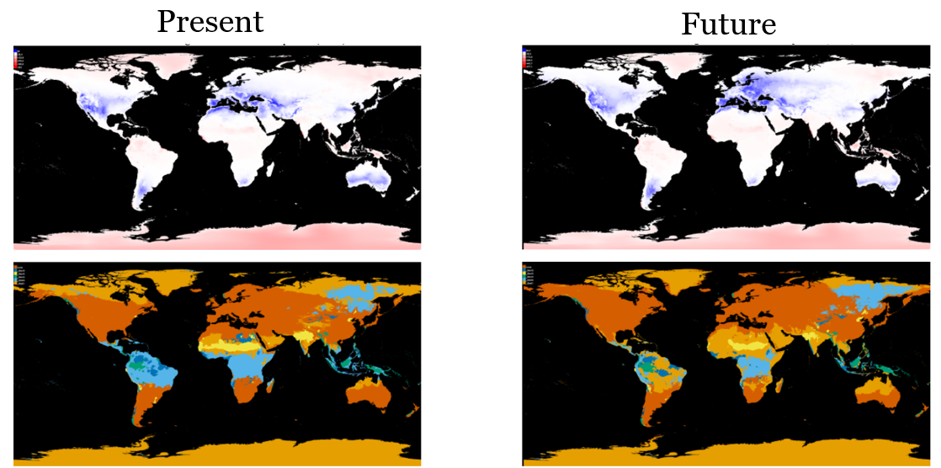

It seems there are not that many differences for the training ranges (Mediterranean) but some visible changes in the tropical areas and around the equator and in the colder regions of the north. Overall this means that in my case, for most of the world and especially my study area around the Mediterranean, Clamping did not have that much of a significant impact. Which is great, I can at least generally my results to the study area.

**Next, we calculate the species range, so remember to calculate the mean value of the threshold you selected because you will need it next.**

# Calculating range-shift changes and the change map:

This is a very straightforward section. The objective here is to calculate where there was loss and gain of species habitat, generate a nice-looking raster that you can then use in ArcGIS to make a nice-looking map. You can also use this information to compare how much are was gained or lost in total for each of the scenarios. For this section, we will use **03_Making_ChangeMaps.R**

**Step by step:**

* Load the needed packages, the rasters and apply the chosen threshold:

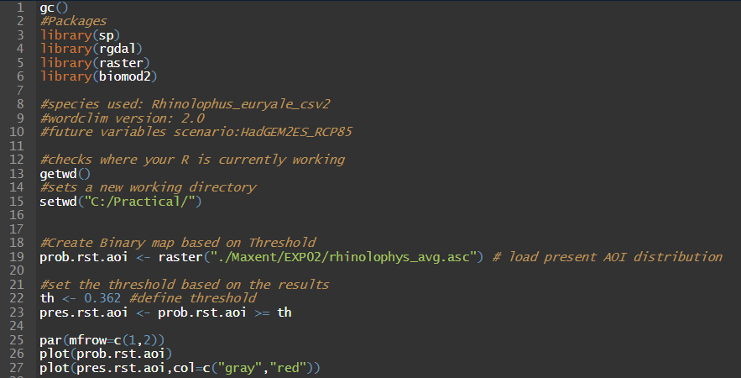

* The command par(mfrow=c(1,2)) tells r that the next plot should have 1 row and 2 columns:

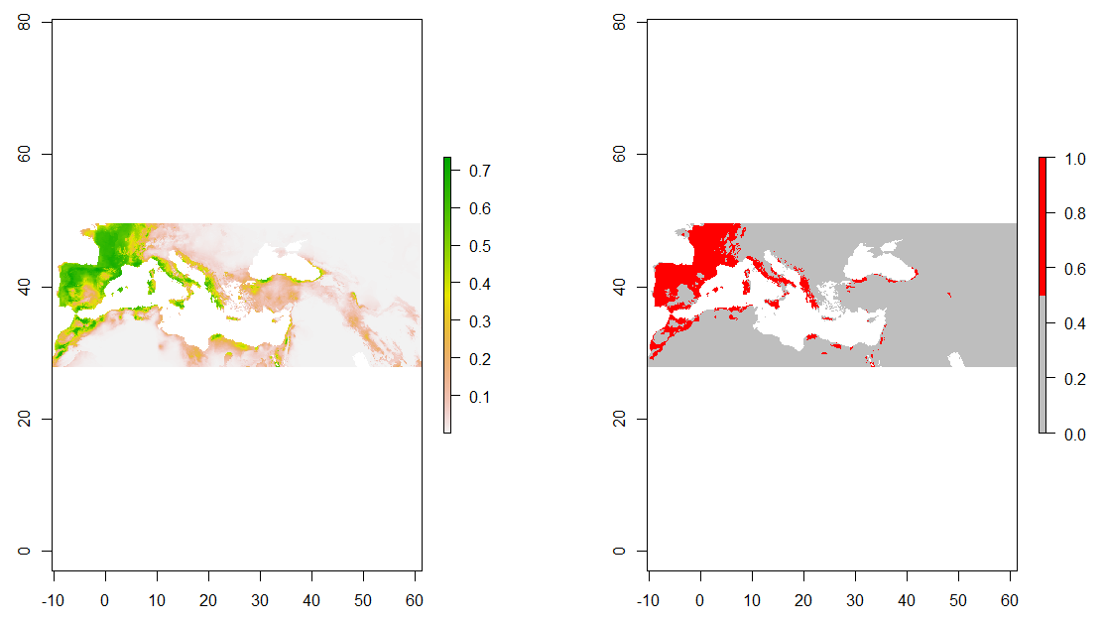

* Let us adapt this code for the remaining scenarios and plot them:

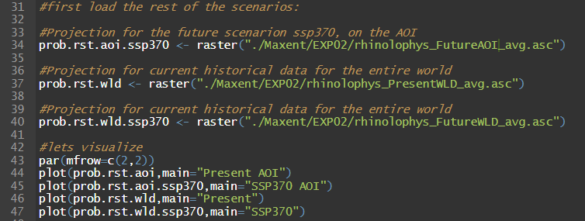

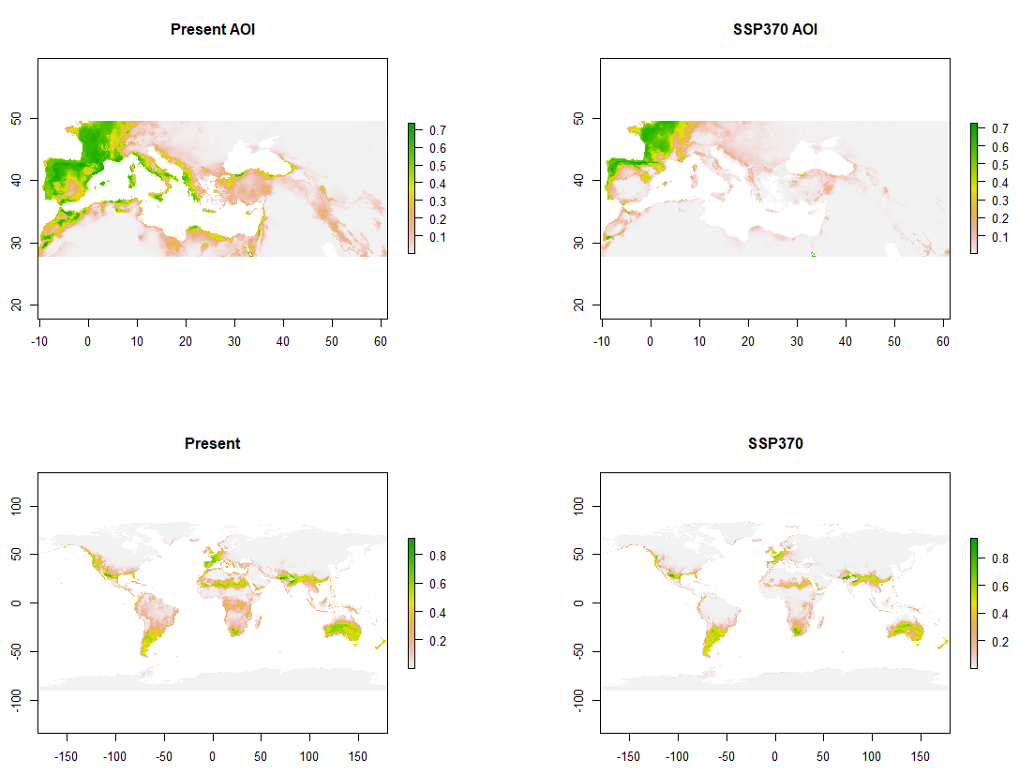

Immediately, we can see that there are definite range shifts in the probability of distribution. We can also now just generate the same output but imposing the threshold.

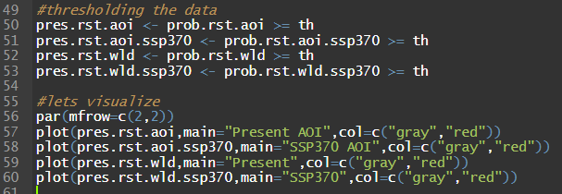

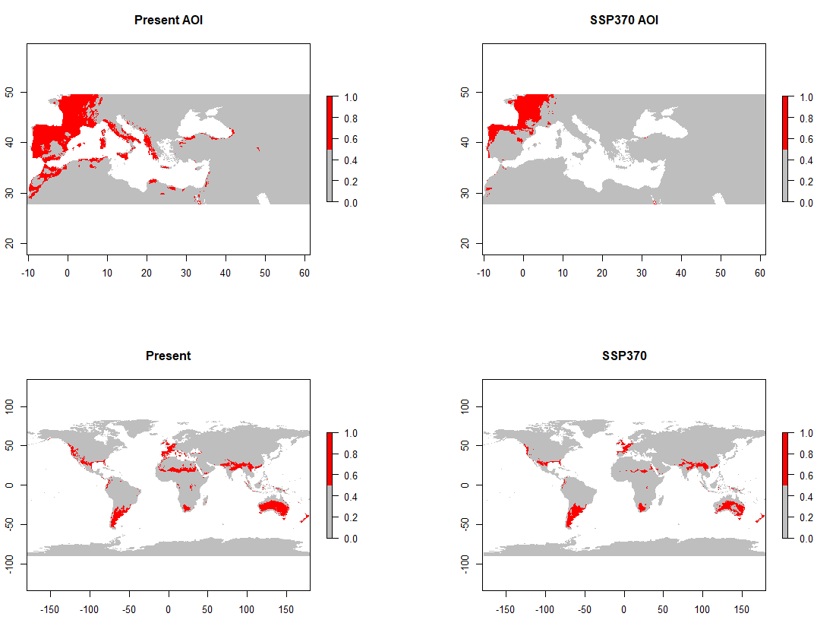

**Which confirms our suspicion that there was some change in the suitability areas. But where did this range shift occur? And where was it a gain or a loss?**

We can easily visualize this using the [BIOMOD_RangeSize](https://www.rdocumentation.org/packages/biomod2/versions/3.3-7/topics/BIOMOD_RangeSize) function in the [Biomod2](https://cran.r-project.org/web/packages/biomod2/biomod2.pdf) package:

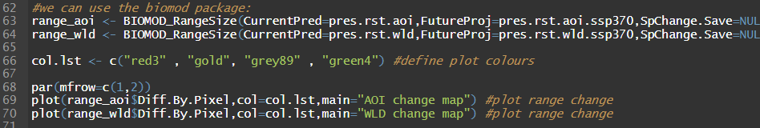

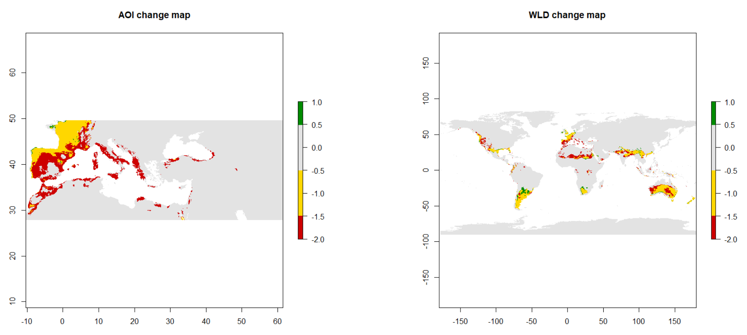

Information the range size and how much it varied in which direction is stored within the object that the BIOMOD_RangeSize function calculates.

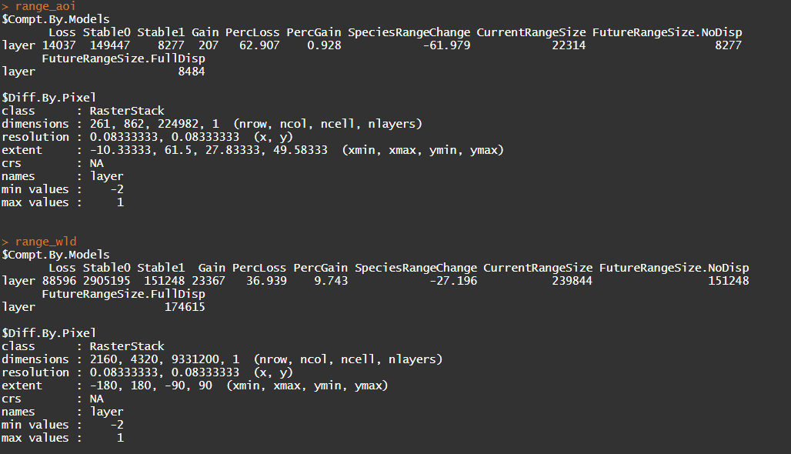



We can confirm then that there was a loss of ~27% of the total area suitable for this species which means that while this species is negatively affected by climate change in the coming ~50 years, it is not critically at risk.

All this analysis could be done in many ways, both in R but also using a GIS software. Once we have the final probability raster’s, it all becomes about using different operations that are available everywhere. **Let us save our outputs to the disc, define their projections so we can easily open them in a GIS and use it to create the maps for your report.**

## Exporting final data to more GIS friendly files:

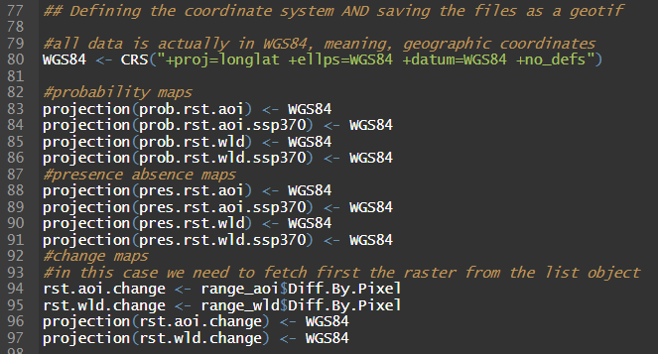

And now, using all that we have learned, we can just save the files to a new folder to make it easier to find. **Remember to create the “FinalOutputs” folder in your workspace.**

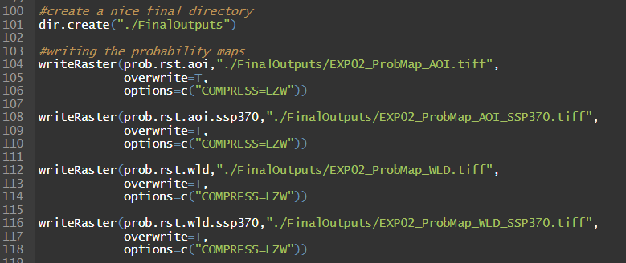

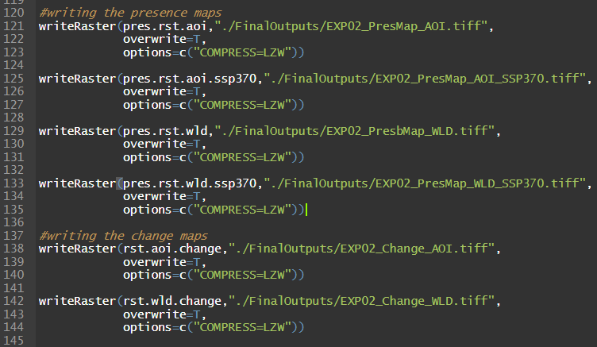

And now, your new folder should have everything there:

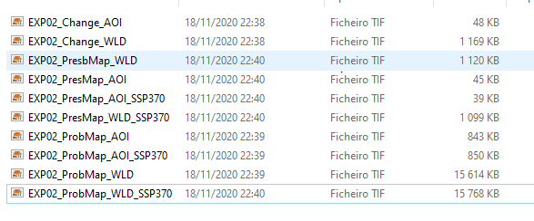

And you should also be able to use all these files seamlessly in a GIS for further analysis and to make even nicer maps. **PS: Adapting these to go fetch the MESS & MOD data should be trivial by now. Perhaps you can also bring those to the GIS and use them to explain your results.**

**Remember the “Golder rules of Cartography”:** <https://www.wwu.edu/huxley/spatial/tut/ALL_GOOD_MAPS.pdf>

1. Title
2. Scale
3. Orientation
4. Border
5. Legend
6. Authorships and data provenance
7. Detail (if needed)
8. Effective graphical design
9. Visual hierarchy
10. **PURPOSE**

These instructions will certainly be useful for the maps in the report.

# A curve ball:

During the preparation of this tutorial I ran the model with the wrong variables and this is the result I got:

**With the right set of variables: AUC= 0.899**

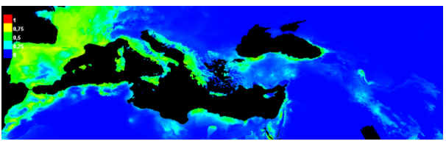

**With the wrong set of variables:** **AUC = 0.901**

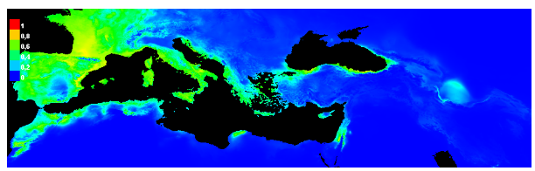

The models are very similar with the accuracy of the wrong model being slightly better. How do you interpret this?

If you want to take a shot at explaining: [n.q.cesar.sa@cml.leidenuniv.nl](mailto:n.q.cesar.sa@cml.leidenuniv.nl)

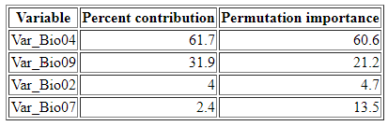And notice:

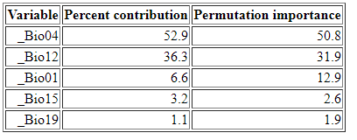

Models trained with the wrong variables can have better accuraccy and also lead researchers towards the wrong conclusions..

# Common R commands:

List (Idaho university): <https://www.webpages.uidaho.edu/~stevel/251/comR.pdf>

This is not an extensive list at all, just some examples that might be useful for the exercise.

**Dataframes: (df)**

* This is the most common object in R. It is the equivalent to a an excel table where (in general) rows represent samples and columns different measurements of those samples.

Importing data as dataframe: <http://www.r-tutor.com/r-introduction/data-frame/data-import>

[summary(df)](https://www.rdocumentation.org/packages/base/versions/3.6.2/topics/summary): produces a summary of the data that is in the dataframe

[head(df)](https://www.rdocumentation.org/packages/utils/versions/3.6.2/topics/head): prints the first (10) rows of the dataframe, lets you quickly investigate big datasets (tail(df) the same but from the bottom).

[rownames and colnames(df)](https://stat.ethz.ch/R-manual/R-devel/library/base/html/colnames.html): prints the row names (often just a sequential 1 to N rows but not always) or the column names of your dataframe.

Changing the dataframe:

df[i, j] <- let’s you change the data in row i and colum j.

df$Newcolumnname <- lets you add a new column to your dataframe. Notice that the values of this column will be added following different rules (<https://www.datamentor.io/r-programming/data-frame/>)

[rbind & cbind](https://www.rdocumentation.org/packages/base/versions/3.6.2/topics/cbind) <- let’s you “collate” a data frame with another dataframe as a row or as a column. Notice that rbind expects that both dataframes have the same column names while cbind expects that both dataframe have the same number of columns.

Loading data as dataframe from csv/txt etc:

**Raster: (rst)**

* Different R packages deal with raster types in different ways. The most commonly used package is probably the [raster package](https://cran.r-project.org/web/packages/raster/index.html), so these examples relate to it.

Loading raster data from files in the computer:

* raster(“path to the file in text”, band=1) loads the raster, by default the first band. It is a single layer raster.
* stack(“path to the file in text”) loads all bands of the raster into a multilayer raster

[names(rst)](https://rdrr.io/cran/raster/man/names.html) <- returns the names of the raster layers. Also lets you change the names of the layer.

[projection(rst)](https://www.rdocumentation.org/packages/raster/versions/3.3-13/topics/projection) <- Returns the current projection of the R object (also applies for spatial data frames). Attention: you can use this to change the projection but not to REPROJECT it’s equivalent to the [define projection in ArcGIS](https://pro.arcgis.com/en/pro-app/tool-reference/data-management/define-projection.htm).

CRS(R spatial object) <- it’s a function of the [sp package](https://www.rdocumentation.org/packages/sp/versions/1.4-4) that creates a CRS class object which can be used to define projection of objects)

[projectRaster(from, to, res, method=”bilinear”,…)](https://www.rdocumentation.org/packages/raster/versions/3.0-7/topics/projectRaster) <- this function actually projects a raster in coordinate system X to coordinate system Y. Can be called in a different way also. This is the function you need to use if you want to go from e.g. WGS84 to a projected coordinate system.

[writeRaster(rst,filename,format,bylayer,suffix,…)](https://www.rdocumentation.org/packages/raster/versions/3.4-5/topics/writeRaster) <- this functions saves the raster data into your folders. This function has many different options:

* bylayer = True ; tells R to store each different layer into a different raster file
* suffix = “numbers” or “names” ; tells R to store each layer using the order in the multilayer raster or the actual layer name.
* You can also change the type of “background value”, or “nodata” value using the background = <some value>
* Most importantly, you can tell R to compress your file by adding (example for GeoTiff files):

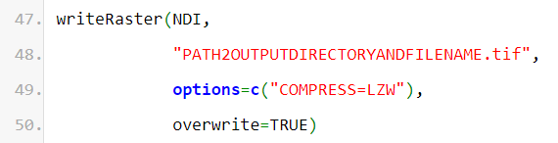

Many raster functions allow to to store your raster at the same time you are using them. For example, [rasterize function](https://www.rdocumentation.org/packages/raster/versions/3.4-5/topics/rasterize) transforms spatial data (e.g. points) to raster data: ([source](https://pastebin.com/K2ZFvi8q))

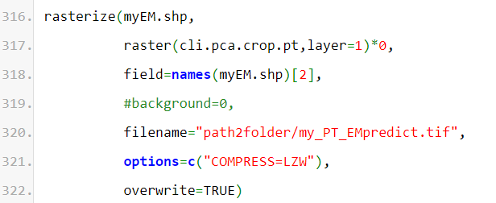

Finally, the raster package allows you to use models trained in R (e.g. [some arbitrary linear model](https://pastebin.com/SahafcNw)):



